# ***The impact of Brexit on the EU economy and the Augmented Synthetic Control Method***

by

Jinhyun, kim

A thesis submitted in partial fulfillment of the requirements for the degree of

## Economics and Business Economics

University of Amsterdam

2021

Date: June 30th, 2021

**Statement of Originality**

# This document is written by Student [Jinhyun, kim] who declares to take full responsibility for the contents of this document. I declare that the text and the work presented in this document are original and that no sources other than those mentioned in the text and its references have been used in creating it. UvA Economics and Business is responsible solely for the supervision of completion of the work, not for the contents.

# **1. Introduction**

For economic and social scientists, the influence of events or interventions at the national level has always been a hot topic. Among them, Brexit is a hot topic. Brexit is a combination of "British" and "exit", meaning a referendum on 23 June 2016 in which the United Kingdom decided to leave the European Union (EU) (Keating, 2021). Brexit was finally carried out on 31 January 2020 at 23:00 after the transition period. This made Britain the first country to leave the EU. This was after 47 years since 1 January 1973, when Britain joined the European Communities, the EU's predecessor. Regulatory and political fluctuations are not predicted because Brexit is an unprecedented case, so many countries are expressing concern about this (Van Kerckhoven, 2021)

The volume of transactions between the UK and Europe is very large and the market size of the EU is the largest single market in the UK. According to government agencies, UK-Europe transactions were valued at 52 billion pounds in 2016, accounting for 47% of UK transactions with all countries in the world (Collins, 2021). This large exchange between the EU and the UK means that Brexit is very influential. That is why we need to understand how Brexit changes the relationship between the UK and the EU.

To examine the changes in relations between the UK and the EU, the Balance of payments (BOP) component representing all transactions between countries was examined. Selected dependent variables are current account, export of goods, export of service, export of goods and services, primary income, and secondary income. Representative economic indicators were chosen as control variables. Chosen independent variables are GDP growth rate, unemployment rate, education index, and inflation.

Augmented SCM was used in this paper. This method is an improvement of the model's shortcomings in the synthetic control method (SCM). SCM is a useful and widely used method for demonstrating the effectiveness of treatment in panel data settings. However, SCM is useful only when there is sufficient data in the pre-treatment, otherwise, it is difficult to use (Abadie and Gardeazabal, 2003). Augmented SCM is a solution for this shortcoming. This model can be used even when the pre-treatment fit is not good (Ben-Michael et al., 2021).

There are not enough papers on which Brexit relates to the EU's economy. Some papers have investigated Brexit's influence using SCM, but no paper has identified economic changes in the EU based on changes in transactions between the UK and the EU. Therefore, this paper will look at how Brexit's influence has changed the UK-EU deal and see the economic impact on the EU. Concisely, we will see how Brexit has affected the EU economy through the Augmented Synthetic Control method.

**2. Literature review**

**2.1 The importance of the UK in the EU**

First of all, before investigating Brexit, it needs to be understood how the UK and the EU are relevant and why this relationship is important. This part will cover what the UK means to the EU and what role the UK has played to the EU.

The UK has played an important role as a financial center for the EU. The role of financial services in the UK industry is the most important part of the UK (Kaya, 2018). Financial services, including insurance and auxiliary services, are the second-largest industries in the economy after the real estate industry. The industry is worth 11.5 billion GBP, which is a 4.1 percent stake in financial services (Heneghan & Hall, 2020). In absolute terms, the UK has the largest financial share in Europe. Also, its financial industry (including insurance and auxiliary services) ranks in the top 10 in the EU economy in terms of the relative size of the economy, accounting for more than similarly large countries such as Germany and France (McRae & Cairncross, 2017).

At the same time, 44% of UK exports of financial services went to the EU. The service went to EU consumers. In addition, exports of financial services to the EU grew stronger over time. The export has doubled in about a decade despite the financial crisis as the EU's stake in exports remains high and stable (Kaya et al., 2018).

So many things are at risk because of Brexit. Without a complete and strong approach to the EU market, these returns are risky. Financial activity may shift to the continent or, worse, completely out of service. That is because services will be provided locally and in a decentralized way. This will probably lead to higher costs and lower liquidity (Morvan, 2021). Providing capital market services to Europe would be less efficient (Pandzic, 2021). Therefore Brexit could pose a serious risk to Britain's most important industry and cause a series of damage to Europe (Kaya et al., 2018).

**2.2 How Brexit could affect the EU economy.**

Like any other modern open economy, the EU economy is complex (Morvan, 2021). There are several ways Brexit can affect EU economy. Economists generally say that a country's productivity depends on three basic factors. The amount of labor, capital, and technology a country has depends on how many people live there and what skills they have, and how and how much they hope to work (Cahuc et al., 2014). Traditionally, capital is buildings, vehicles, and machinery. However, it is also important to have intangible capital, such as a good brand, in a service-based industry (Corrado et al., 2009)

The third element, technology, has transformed the standard of living in the world, which has evolved since the early 19th century (Burke, A., 2000). New inventions such as electricity, mass production, better management strategies, and paperclips have increased the amount workers can produce per day (McCarthy, J., & Wright, P., 2004). In other words, technology increases workers' productivity.

But there is no point in producing if no one wants to buy. Therefore, the output of the EU economy also depends on how much there is a demand for goods and services (Weber, 2019).

Since the EU is an open country to trade, this demand does not depend solely on EU governments' businesses and consumers, but on how many consumers around the world want to buy and how much they want to buy (Hodson, 2010). This means that when identifying the economic situation of the EU, it is heavily affected by the economic situation of other countries abroad. That is why it is necessary to see aspects of relations between the UK in the analysis of EU economic conditions (Hix, 2018).

There are many things that Brexit can influence the EU economy. Some of the factors that were thought to be very influential are as follows. Trade, foreign direct investment, the number and type of workers, and productivity (Pain, N., & Young, G., 2004). The following paragraph will explain how these factors are important and can affect the EU economy.

**2.3 Factors that can affect EU economy**

**2.3.1 Trade**

A large amount of European economic output is a picture for overseas buyers. British consumers also live in large quantities overseas. Economists argue that for a long time trade can improve the standard of living in the countries involved (Marshall, 2015). Each country can produce more and consume more by focusing on producing goods and services with relative benefits. That is why a country's brisk trade can bode well economically. On the contrary, less international trade is likely to bode ill economically.

There are a number of factors that boost trade. Price is indispensable if the main factors that affect trade are listed. Consumers are heavily affected by prices when buying products or using services. Therefore, to consider whether EU trade has been affected by Brexit, it is necessary to consider the variables that affect prices.  
 Even if there is the same price change, the degree to which consumers accept price changes varies from country to country. It could be a minor price change for a well-off country, or a large price change for a poorly-off country. Therefore it is necessary to define international consumers first in determining the impact of Brexit.  
 Because of the influence of Brexit, international consumers in the EU were thought to be divided into countries other than the UK and the UK. Brexit will have little effect on countries other than the UK because it is about the relation between the EU and the UK (Tetlow & Stojanovic, 2018). Of course, the knock-on effects can cause Brexit's aftermath in countries other than the EU. However, this was not considered because the knock-on effects are likely to occur over a long period of time and Brexit has not been around long-term. In summary, only the UK will be considered in terms of current international relations with the EU.

Cost is an important factor in pricing goods and services. There are three other costs besides simple local production costs such as material costs. First, there is the cost of transport. This will increase the cost of trade with countries (Levin & McEwan, 2000). This cost becomes more expensive the farther it is sent.

The second is tariffs. In other words, taxes imposed on imports of EU goods will be added to the cost of EU goods in the UK (O'rourke, 2000). Countries in the EU do not tax each other (Helminen, 2011).

A third non-tariff barrier will be added to the cost of goods and services in the EU (O'rourke, 2000). Non-tariff barriers are, of all things that stand in the way of trade, not tariffs. Some of these barriers are heavily influenced by government policy (Johnson, 1953). Examples of this policy include standards for goods to be produced to meet certain standards. These standards allow people to provide services with special professional qualifications, or cultural differences between countries that hinder trade (O'rourke, 2000).

Two major non-tariff barriers are trade barriers and tariffs. Regulatory barriers are bound to arise as long as other countries have legal regulations in things like health, safety, and environmental protection (Shleifer, 2005). Customs inspection (including paperwork at the border) causes delays and costs (Mineo et al., 2016).

Brexit can affect the extent of these tariffs. EU and UK tariffs and non-tariffs may be higher or lower than non-EU countries, depending on the circumstances. One of the reasons it can be lowered is that the EU and the UK start with the same regulations (Pandzic, 2021). However, there may be barriers depending on the negotiations (Heneghan & Hall, 2020). For example, if the UK is outside the EU Customs Union, exporters may have more money to do additional paperwork. The EU also provides less access to financial services and fewer markets for other businesses outside the single market.

Whether barriers change in trade with the UK depends on the weight of the trade (Pandzic, 2021). For example, any changes in trade barriers with the EU will have a significant negative effect on UK growth in the medium term, as transactions with the EU account for about half of UK exports and imports. And this will outweigh the positive effects of removing trade barriers with China. In the long run, UK trade will be directed to countries with low barriers to trade (Levin & McEwan, 2000). However, the total profits will be smaller than the losses made with the EU. This can be seen by considering that the EU is a large economic region (14% of the world's PPP) and is close (Hartley et al., 2020).

**2.3.2 Foreign direct investment**

Investment is the most important factor in long-term GDP growth. Both domestic and public investments and overseas investments will increase the number of mechanical buildings and technologies and increase technological advances and productivity (Paul & Feliciano-Cestero, 2021). Over time, barriers to trade worldwide have been reduced, and cross-border investments have also increased (Contractor et al., 2020).

Foreign direct investment (FDI) directly contributes to national income, which allows companies to further expand their businesses (Aust et al., 2020). It can also improve productivity by making it easier for companies to access new ideas from around the world.

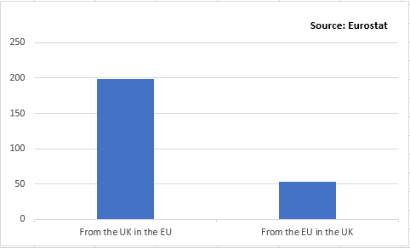

Figure 1. Foreign direct investment in the financial sector, Stock in EUR bn (2015)

Prior to Brexit, the EU had benefited a lot from Foreign direct investment (FDI) for the UK. Figure 1 shows the amount of FDI from the UK to the EU in 2015. The amount is about 200bn EUR, not a small amount. On the other hand, the EU only invests in the UK at 50bn EUR or a quarter of the UK FDI. It can be seen that changes in FDI caused by Brexit can be relatively minimal to the UK. In other words, due to Brexit, the impact of FDI is almost on the EU.

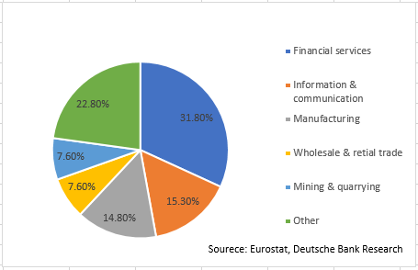

Figure 2. UK firms' FDI in the EU (of stock, 2015)

Figure 2 shows the configuration of Foreign direct investment sent by the UK to the EU. This shows that the proportion of financial services is the highest at 31.8%. This segment is likely to be affected by Brexit, which is described in the following paragraphs.  
 First of all, Brexit can discourage foreign investors. There are at least two reasons why the UK can cause foreign investors to lose interest if it does not become a member of the EU:  
  
1. Free movement of capital facilitates EU member countries to invest in the UK (Kirkegaard, 2020).

2. Being in the EU's single market has made the UK an attractive investment destination for multinational companies. These multinational companies can use the UK's relatively attractive business environment and trade with the EU (Wang & Li, 2021).

For these reasons, Brexit could cause foreign investors to lose investment interest in the UK. This could have a negative impact on the financial sector of the UK. These results could later affect investment in the financial service sector from the UK to the EU (Ahir & James, 2021). In other words, the FDI from the UK could change in the EU.  
 Overall, data from Organisation for Economic Cooperation and Development (OECD) also showed that EU membership contributed significantly to the growth of FDI in the UK (Macinko, J., Starfield, B., & Shi, L., 2003).

**2.3.3 Productivity**

Increased productivity bodes well for any economy. More productive means that workers produce more and more quality products (Syverson, 2011). Without the addition of special capital, productivity is a very important issue in increasing living standards. Nevertheless, the factors affecting productivity growth have not been well identified (Alcalá & Ciccone, 2004). But what is clear is that productivity is one of the key elements in the country. It can affect many parts of society, including politics, economy, and law.

**2.3.4 Number and type of workers**

Doing all the other things the same, with more workers or more skilled workers, more output will be generated in the EU. (Cho & Newhouse, 2011) Alternatively, workers' technologies complement each other to make better outputs (Groysberg & Nanda, 2008).  
 The productivity and quality of labor depends not only on how many people are born in the EU, but also on how many immigrants enter the country (Syverson, 2011). When you are a member of the EU, it is difficult to stop immigrants from other EU countries if they have a job. This disablement is one of the important factors that caused Brexit from the UK (James & Quaglia, 2020). Therefore, one of the important factors that Brexit can influence economic growth is the change in immigration policy. This change could limit the number of immigrants from the UK to EU countries (Mallet-García & García-Bedolla, 2021).  
 Changes in the number of immigrants can also affect productivity, which can later affect the overall economy, such as EU GDP. The direction of this effect is theoretically ambiguous. In some ways, UK immigrants may have complementary skills with EU workers. Or EU workers could step up efforts to improve their skills (Syverson, 2011). Or, on the other hand, UK immigrants could simply replace existing EU workers and have only a negative impact (Alcalá & Ciccone, 2004).

**3. Data**

**3.1 Data design**

Annual national panel data were set as a period from 2006 to 2020. The sample of countries consists of seven countries. The countries that comprise are as follows. Brazil, Canada, China, India, Japan, Russia, Switzerland, and the United States. This is the result of choosing to reduce bias by having the diversity of countries dealing with the UK. The selected countries meet the following conditions. It should be a country with a lot of trade volume with the UK and not affected by Brexit.

Dependent variables were chosen to reflect the variables mentioned in the section on how Brexit could affect the EU. The factors mentioned earlier in the literature review that Brexit could affect the EU economy are as follows. There are trade, FDI, productivity, types, and numbers of workers. Selected dependent variables are current account, exports of goods from the UK to the EU, exports of services from the UK to the EU, exports of goods and services from the UK to the EU, the credit of primary income for the EU in the UK, and the credit of secondary income for the EU in the UK.

**3.2 Reasons for data selection**

The reasons for choosing data based on UK rather than EU standards are as follows. Since the UK is the center of the world's trade transactions, the comparison between the UK and non-EU countries was judged to be more objective in determining the impact of Brexit. The following paragraphs will explain why these dependent variables were chosen.  
 First, the Current Account is to identify the overall trade aspect between the EU and the UK. This allows us to identify which countries are benefiting as a whole and whether there is a change in the overall trade pattern.  
 Secondly, the export of goods will determine the impact of tariffs. As mentioned earlier in the paper review, one of the factors that greatly affect the import and export of goods is price, which can be heavily influenced by tariffs. It was thought that the most direct and quickest effect of tariffs was on goods trading. So the UK's export of goods was chosen as the second dependent variable.  
 Third, the export of service was chosen because this variable identifies the number and type of workers, productivity, and changes in financial exchanges between the UK and the EU. The increase in export of services can be seen in a similar vein to the increase in the number and types of workers in the EU. The UK's provision of labor services can also be seen as receiving a diverse workforce in the EU. The increase in various services brings synergy to the workforce, which can also lead to increased productivity.

Of course, an increase in various services may not lead to an increase in productivity. However, it was thought that the export would lead to a good effect because the EU would receive the only necessary labor services. So the export of service was chosen.

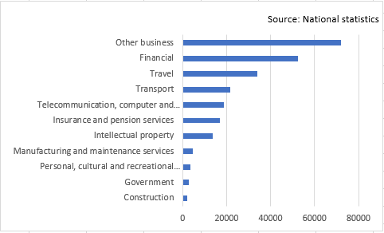

Figure 3. Exports of services from the UK to the EU (£ million, 2015)

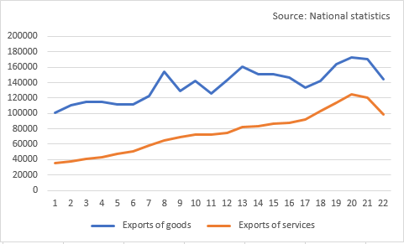An additional reason for choosing to export services is that the UK plays an important role as a financial services center. This document serves as an important financial services center for the EU. What can be seen in Figure 3 is that financial services exports accounted for the largest portion of service exports, excluding other businesses. In view of this, changes in service exports could once again be confirmed to be appropriate for selection as a dependent variable.

Figure 4.UK Export of goods and services (£million, 2015)

The export of goods and services was then chosen to determine the result of the combined effects of each of the two variables mentioned earlier. Figure 4 shows that the export of goods and the export of services are similar but a little different. Therefore, it is necessary to grasp the results of combining the two.

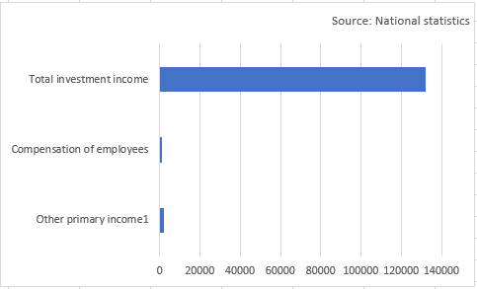

Figure 5. UK credit of primary income (£ million, 2015)

To identify changes in FDI, we identified changes in primary income. Primary income refers to the net flow of dividends, profit, interest, and remittance of workers from other countries (McCombie & Thirlwall, 2016). This income consists of the Compensation of employees, Total investment income, and other primary income. As it can be seen in Figure 5, primary investment takes the largest proportion. This investment includes indicators of foreign investment, including earnings on portfolio investment, earnings on direct investment, and earnings on debt securities. So it was considered that the change in FDI from the UK to the EU would also reflect well.  
 Finally, secondary incomes were selected to confirm whether laws have changed between governments. Secondary income refers to the difference in foreign currency exchanged free of charge (McCombie & Thirlwall, 2016). If there is a change between variables, the overall change in foreign currency laws between countries can be identified, which allows indirect identification of changes in laws between governments.  
 Control variables were selected among representative economic indicators. Chosen independent variables are GDP growth rate, Unemployment rate, Education index, and inflation. Various growth predictors have been used, but nothing has changed much.

**3.3 Descriptive statistics**

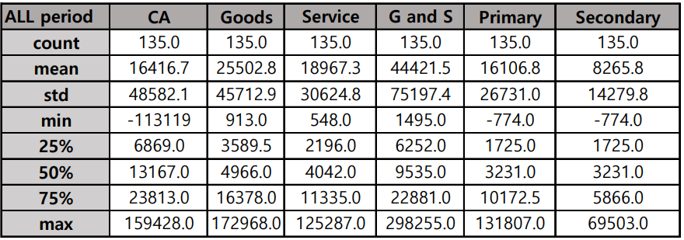

Table 1. Descriptive statistics of dependent variable for all period (2006-2020), £ million

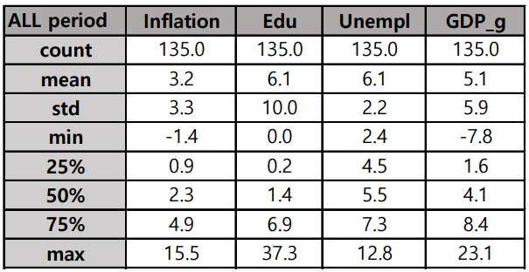

Table 2. Descriptive statistics of independent variable for all period (2006-2020), £ million

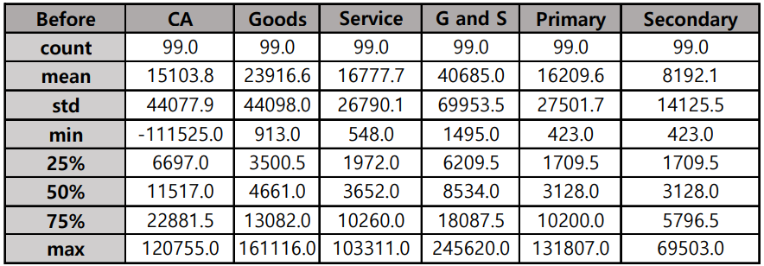

Table 3. Descriptive statistics of dependent variable before Brexit (2006-2015), £ million

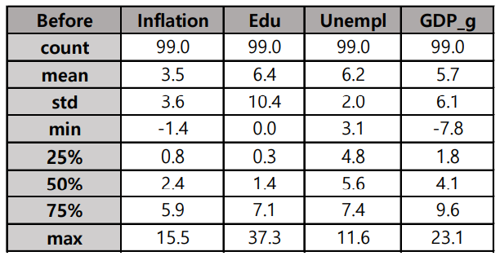

Table 4. Descriptive statistics of independent variable after Brexit (2006-2015), £ million

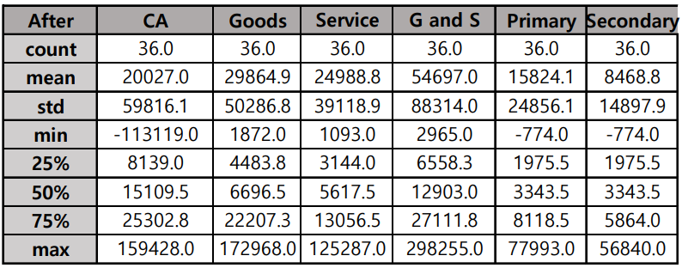

Table 5. Descriptive statistics of independent variable after Brexit (2016-2020), £ million

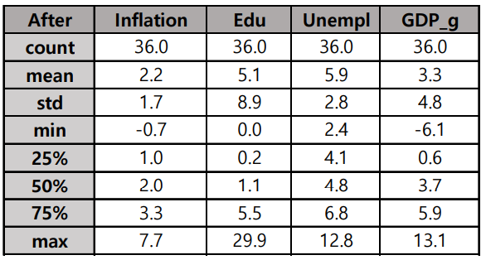

Table 6. Descriptive statistics of independent variable after Brexit (2016-2020), £ million

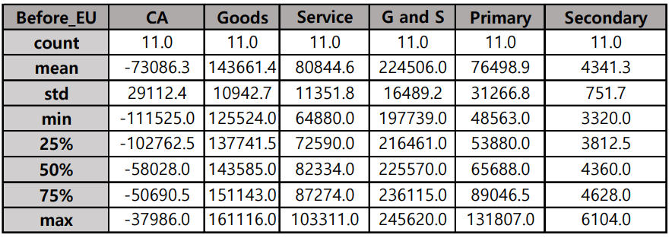

Table 7. EU Descriptive statistics of independent variable before Brexit (2016-2020), £ million

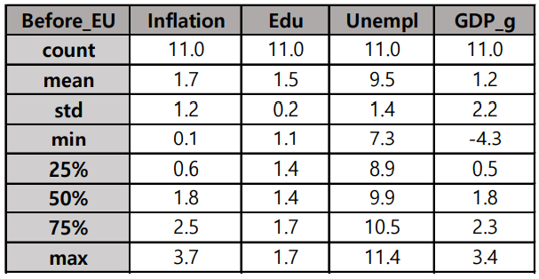

Table 8. EU Descriptive statistics of independent variable before Brexit (2016-2020), £ million 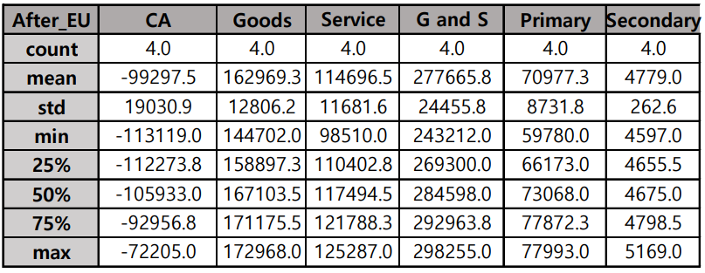

Table 9. EU Descriptive statistics of dependent variable after Brexit (2016-2020), £ million

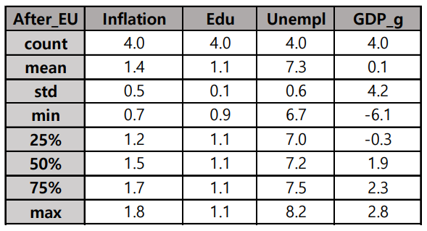

Table 10. EU Descriptive statistics of independent variable after Brexit (2016-2020), £ million

The tables above are descriptive statistics to determine Brexit's influence. Each variable in the table above are: CA, Goods: Service, G and S, Primary, Secondary, Inflation, Edu, Unempl, and GDP_g. The meanings of these variables are as follows. current account, exports of goods from the UK to the EU, exports of services from the UK to the EU, exports of goods and services from the UK to the EU, the credit of primary income for the EU in the UK, and the credit of secondary income for the EU in the UK, inflation, education index, unemployment rate, GDP growth rate.  
 Tables 1 through 6 are descriptive statistics obtained for the entire sample as a whole. Table 7 through Table 10 is descriptive statistics obtained only through trade deals between the UK and the EU.

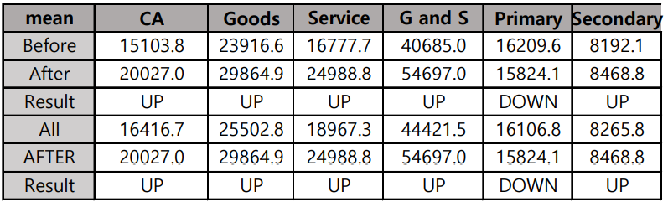

Table 11. Changes of means after Brexit, £ million

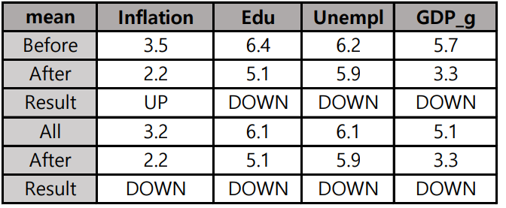

Table 12. Changes of means after Brexit, £ million

Table 11 and Table 12 allow us to check the results of changes in the means of dependent variables and independent variables in the countries of the entire sample. Additional variables include Before, After, Result, and All, which means: Before Brexit, After Brexit, Result of Change, and All period. Table 11 shows that all variables have increased since Brexit except the credit of primary income for the EU in the UK.

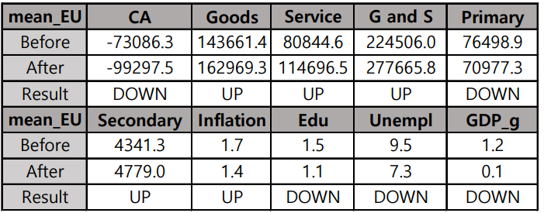

Table 13. EU Changes of means after Brexit, £ million

Table 13 shows the result of changes in dependent and independent variables since Brexit between the UK and the EU. All variables are similar to the changes in the whole sample. UK transactions with the EU saw their Current account and credit of primary income fall and all the remaining dependent variables rise. Comparing this change to Table 11, we can see that the transaction pattern of the UK and EU shows the same change except the Current account.  
 The UK's independent variables have almost the same pattern of change as other countries. All variables except Inflation went down after Brexit. This allows us to assume that most countries are in a similar overall economic situation.

**3.4 Hypothesis**

From the descriptive statistics above, six hypotheses were made as follows.  
  
***Hypothesis 1***  
UK's current account with EU < ASCM  
(= UK's current account with the EU has been reduced by Brexit.)

***Hypothesis 2***  
UK's export of goods to EU > ASCM  
(= The UK's export of goods to EU with the EU has increased due to Brexit.)

***Hypothesis 3***  
UK's export of services to EU > ASCM   
(= The UK's export of services to EU has increased by Brexit.)

***Hypothesis 4***  
UK's export of goods and services to EU > ASCM   
(= The UK's export of goods and services to EU has increased by Brexit.)

***Hypothesis 5***  
The credit of primary income for the EU in the UK > ASCM   
(= The UK's export of goods and services to EU has increased by Brexit.)

***Hypothesis 6***  
The credit of secondary income for the EU in the UK > ASCM

(= The credit of secondary income for the EU in the UK has increased by Brexit.)

Here, ASCM is based on pre-Brexit data to guess what would be really like without Brexit. ASCM will be explained in detail in the Methodology part. In other words, the ASCM is expected figures based on the assumption that Brexit is not affected. For example, if hypothesis 1 UK's current account with EU < ASCM is not rejected, it means that UK's current account with EU is actually reduced by Brexit. Conversely, if it is rejected, the Brexit effect was not significant.  
 This paper will now confirm whether the above hypotheses are valid or not. If these hypotheses are not rejected, it can be concluded that the change in the relationship between the UK and the EU was changed by Brexit, as confirmed by descriptive statistics. If the hypothesis is not established, it can be concluded that Brexit did not have a significant impact on changes in relations between the UK and the EU.

**4. Methodology**

**4.1 Augmented Synthetic control method**

Choosing a comparison target is an important process in comparative case study research. If inappropriate comparisons are chosen, this can lead to false results. If the comparison is not the same as the initial survey, the difference between the two will be too great, making it difficult to do the right survey. (Geddes 2003; George and Bennett 2005; King, Keohane, and Verba 1994). Augmented Synthetic comparative studies are useful in doing comparative studies.  
 The most important thing in conducting comparative studies is to determine how the comparison target is chosen over the features of each data. Augmented Synthetic control method (ASCM) is an extension of Synthetic control method (SCM). Synthetic control is based on a simple but very useful idea. There is no need to find a comparison group this way. Instead, comparisons can be created through synthetic control (SCM). In SCM, the measurement of the effectiveness of each enterprise is basically possible by comparing the resulting variable differences between the created unit and the control group (Abadie et al., 2010). If solved, SCM is a methodology for generating a synthesized control group of counters based on data over the pre-treatment period and quantitatively interpreting the differences in the resulting variables between the two groups during the post-treatment period (Larson & Halldorsson, 2002)

However, it is not always possible to actually obtain a perfect or near-perfect pre-treatment fit. By definition, the conditions for near-perfect weights are only possible when the vector of the created unit is within the convex hull of control unit. According to Abadie et al. (2015), the pre-treatment fit is not good when the pre-treatment period is small. Therefore, there are many restrictions on using SCM in practice. SCM was also intended to be applied in this study, but it was confirmed once again that it was difficult to apply (See Appendix A). Augmented SCM is a solution for this shortcoming. This model can be used even when the pre-treatment fit is not good.

**4.2 Constructing Augmented synthetic control**

To estimate the effectiveness of Brexit with the Augmented Synthetic Control Method (ASCM), we will create a fake unit. This is during the period prior to intervention. Then we'll see how these fake units act after the intervention. The difference between Augmented synthetic control and imitated unit here is the treatment effect.

To find the optimal weight of samples we will use Ridge regression. Ridge is a type of model that has used multiple regularization methods to increase the accuracy or interpretability power of linear regressions (Marquardt & Snee, 1975). We will minimize the difference between the weighted average of the unit in the donor pool and the trained units in the pre-intervention period.

The first thing to do is to change the unit to a column and prepare a dataset with a time of row. Then we will create Augmented Synthetic Control. During the pre-intervention period, we will create figures very similar to dependent variables and then see how it works in the post-intervention period. For this reason, it is important to select only the data in the pre-intervention period. Here feature should be in the same unit. Otherwise, there will be skewed consequences that show that greater features are more important.

**4.3 Robustness check**

**4.3.1 Placebo study**  
 Placebo studies are useful when validating the results of the analysis when conducted with fewer samples. The feasibility assessments here include placebo test in time and placebo test in space. The in-time placebo effect is to check when an event has been moved to a different point in time, and in-space placebo effect is to analyze the effect of an event that occurred in another space (Abadie et al., 2010). For example, in-time placebo effect is to assume that Brexit occurred in the 1990s, not in 2016. And in-space placebo test works by assuming that Brexit happened in other countries, such as the United States and Brazil, not Britain and Europe. In-time-placebo was determined to be unavailable due to the short duration of the selected data. So it was decided to use only in-space-placebo.

A p-value was specified to clarify the results of the placebo study. The denominator is designated as the total number of sample groups. Furthermore, the numerator designates a case in which the placebo effect is greater than the absolute value of the treatment effect. For example, suppose Brexit's impact came from investment is greater in China than in the EU. Then the placebo effect of China is greater than the EU treatment effect. If only the placebo effect of China is larger in a sample group, the numerator is 1. Each impact was compared to the absolute value and the impact was identified each year.

**4.3.2 Limiting pool of donors**

As mentioned earlier in the data section, there are eight countries selected for comparison: Brazil, Canada, China, India, Japan, Russia, Switzerland, and the United States. Comparing eight countries is likely to pose difficulties in conducting detailed comparative studies. The details will be explained in the following paragraphs.  
 There are many variables to consider in order to compare multiple samples. For example, there are two assumed cases in comparing the effects of Brexit. The first case considers only the UK and the EU, and the second case compares the three countries, UK, EU, and China. Unlike the former case, the latter needs to additionally take into account the fact that China is in Asia and the market structure is different. Simply comparing changes between the respective economic indices of the UK, EU, and China is likely to undermine the accuracy and credibility of the study. To put it succinctly, selecting multiple samples can undermine the credibility of comparative studies. However, simply increasing the number of samples can be problematic, which will be explained in the following paragraphs.  
 Simply reducing samples of ASCM to increase accuracy can cause problems. If the sample size decreases, the pre-treatment fit decreases (Abadie et al., 2015). If the pre-treatment fit decreases, ASCM will not be able to properly represent the post-Brexit figure. Therefore, it is necessary to know how there is a correlation between the size of the sample and the pre-treatment fit.  
 The method described in Abadie et al. (2015) will be used to determine the aforementioned correlation. This method subtracts the number of countries in the sample one by one during the pre-treatment period to see the difference between ASCM and the actual values. Then the goodness of fit will be identified for any changes. Through this result, it will be checked what the advantages of sampling multiple countries are rather than selecting fewer countries as samples.

In addition, this method will also check the consistency of results. If the final result changes as the countries selected for sample groups, this result is not significant. Therefore, we will make sure that each sample has the same significant result after subtracting one country.

**5.Results**

**5.1.1 Current account**

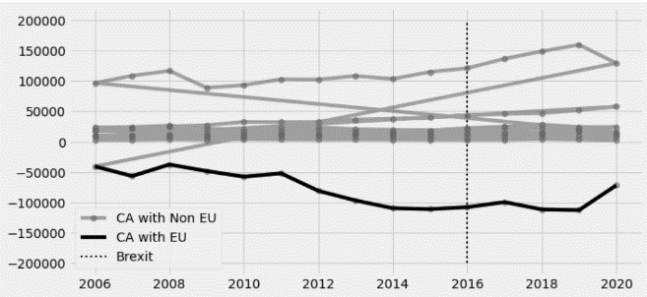

Figure 6 UK Current accounts with EU and Non-EU

Figure 6 shows how Current accounts in the UK and other countries change. If lines go down here, it means that the current account in the UK decrease, indicating that the UK is losing money. On the contrary, if the line is in an upward trend, it means that Britain will benefit. In other words, the UK's CA is in the opposite direction to the EU's CA. After Brexit, the UK's CA is rising or maintaining in most countries. This can be inferred that Britain is a beneficiary of Brexit. Augmented synthetic control methods were used to verify that this was really the case.

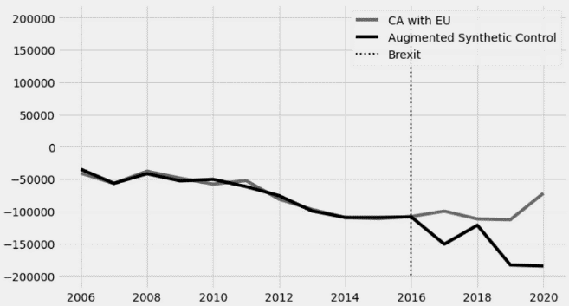

Figure 6. Augmented Synthetic Control (CA)

In the figure above, the period between 2006 and 2016 shows that the composition of the synthetic control group, which is the comparison target for the treatment group, is appropriate. The RMSPE value, the mean square root of the measurement error for the period, is 0.09143, indicating that the error is minor.

|  |  |  |  |
| --- | --- | --- | --- |
| Table 1.Brexit's impact on CA , £ million | | | |
| **Year** | **CA** | **Ridge ASCM** | **CA – ridge ASCM** |
| 2016 | -108255 | -108756.64 | 501.640 |
| 2017 | -99874 | -151029.921 | 51155.92 |
| 2018 | -111992 | -121755.425 | 9763.425 |
| 2019 | -113119 | -183268.355 | 70149.356 |
| 2020 | -72205 | -184849.152 | 112644 |

According to Table 5, Brexit's impact on CA was 501.670, 51156.058, 9764.453, 70149.415, and 112644, respectively, from 2016 to 2020. The value of ASCM is lower, meaning that the CA affected by Brexit is higher than the CA unaffected. In other words, Brexit has raised the EU's CA on the UK side. In other words, the EU has been affected by Brexit and CA has been lowered.

To test the reliability of our work, we conducted an in place placebo study. In this study, the treatment of interest was applied to other countries in the year other than 2016. In placebo studies, as mentioned earlier, there are in time placebo and in place placebo. Here in time placebo was not used because the sample data did not last long.

Transactions with the EU represent a Treatment effect, which in other countries is a placebo effect. This effect is to estimate the ASCM effect where the treatment effect has not occurred. If we draw all the placebo effects with the UK EU, we can see whether the effect of treatment is greater than the placebo effect, so it is significant.

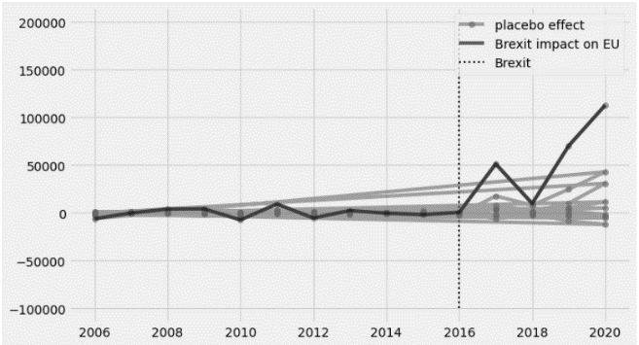

Figure 7. Placebo effect (CA)

Figure 5 shows that the impact on UK-EU transactions is larger than on UK-other countries. Therefore, the analysis of CA transactions between the UK and the EU is significant. In conclusion, then, the EU as a whole suffered losses from Brexit in its dealings with the UK.

**5.1.2 Goods**

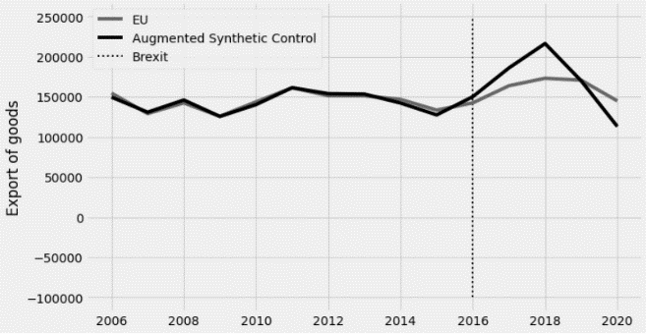

Figure 8. Augmented Synthetic Control (Export of goods)

Export of goods refers to the extent to which goods are exported from the UK to the EU. The increase in Export of Goods means increased diversity in EU products. In the figure above, the Export of Goods 2006–16 is similar to ASCM. The mean square root of the measurement error during the treatment period, RMSPE, is 0.028, indicating that the error is low. This minor error means the goodness of fitting is good.

|  |  |  |  |
| --- | --- | --- | --- |
| Table 2. Brexit's impact on Export of goods, £ million | | | |
| **Year** | **Export of goods** | **ridge ASCM** | **Exports of goods– ridge ASCM** |
| 2016 | 142309 | 149980.635 | -7671.635 |
| 2017 | 163629 | 185828.546 | -22199.546 |
| 2018 | 172968 | 216228.398 | -43260.399 |
| 2019 | 170578 | 169758.439 | 819.560 |
| 2020 | 144702 | 112840.461 | 31861.539 |

The differences between the actual exports of goods and ASCM between 2016-2020, the period that Brexit affects the EU are -7671.635, -22199.546, -43260.399, 819.560, and 31860.539. This result means that exports of goods from the UK to the EU will decrease from 2016 to 2018. Since then, exports of goods to the EU have increased.

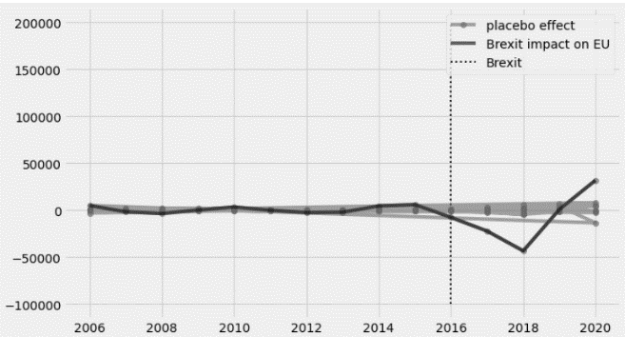

Figure 9. placebo test (Export of goods)

As a result of the analysis of these changes in Export of Goods, the in place placebo test was implemented to verify the feasibility. Figure 11 illustrates that the p-value is zero in all years from 2016 to 2020. This means that the change in goods exports since Brexit in the EU and UK has been greater than in all countries. Therefore, Brexit's EU and UK's goods export changes.

**5.1.3 Service**

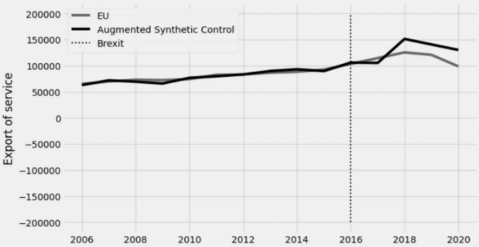

Figure 10. Augmented Synthetic Control (Export of services)

Export of service is the degree of service exported from the UK to the EU. The increase in export of services can be interpreted as the increase in the EU's workforce. In the figure above, the Export of service for 2006 to 2016 is similar to ASCM. The mean square root of the measurement error during the treatment period, RMSPE, is 0.0437, indicating that the error is low. This represents service exports from the UK to the EU by ASCM to the EU.

|  |  |  |  |
| --- | --- | --- | --- |
| Table 3.Brexit's impact on Export of service, £ million | | | |
| **Year** | **Export of services** | **ridge ASCM** | **Exports of services – ridge ASCM** |
| 2016 | 142309 | 105766.845 | -2455.845 |
| 2017 | 163629 | 105155.971 | 9211.029 |
| 2018 | 125287 | 151091.130 | -25804.130 |
| 2019 | 120622 | 140529.045 | -19907.045 |
| 2020 | 98510 | 129979.848 | -31469.848 |

The difference between actual CA and ASCM between 2016-2020, after Brexit happended, is -2455.845, 9211.029, -25804.130, -19907.045, -31469.848, which means that the amount of export of service has decreased except 2017.

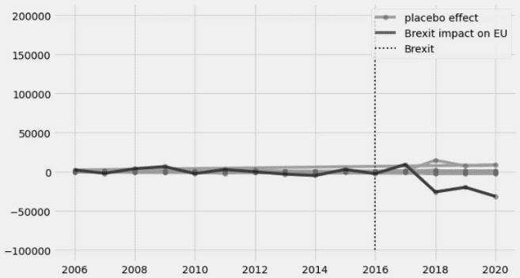

Figure 11. placebo test (Export of services)

The following shows that the p-value is zero in all years from 2016 to 2020. This means that the changes in exports since Brexit in the EU and the UK have been greater than in all countries. Therefore, Brexit's change in service trade between the EU and the UK is significant.

**5.1.4 Goods and Service**

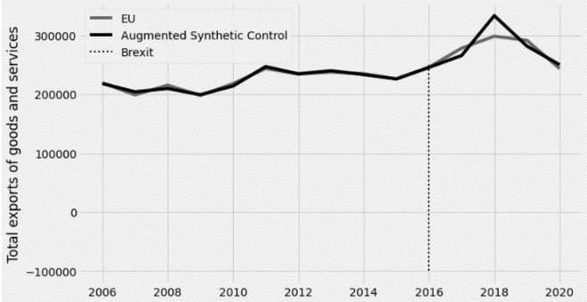

Figure 12. Augmented Synthetic Control (Export of goods and services)

Export of goods and services is the amount of goods and services exported from the UK to the EU. The increase in Export of Goods and Services represents an increase in the diversity of EU labour products in the EU. In the figure above, the Export of Goods and Services for 2006 to 2016 is similar to ASCM. The mean square root of the measurement error during the treatment period, RMSPE, is 0.014 indicating that the error is low. This represents goods export from the UK to the EU.

|  |  |  |  |
| --- | --- | --- | --- |
| Table 4.Brexit's impact on Export of Goods and Services, £ million | | | |
| **Year** | **Export of Goods and Services** | **ridge ASCM** | **Exports of services – ridge ASCM** |
| 2016 | 277996 | 265426.595 | 12569.404 |
| 2017 | 298255 | 333142.573 | -34887.575 |
| 2018 | 291200 | 281427.069 | 9772.930 |
| 2019 | 243212 | 249901.821 | -6689.821 |
| 2020 | 277996 | 265426.595 | 12569.404 |

The difference between the actual Export of goods and services and ASCM between 2016-2020, the period that Brexit affects the EU, is 12569.404, -34887.575, 9772.930, -6689.821, 12569.404. This indicates that Brexit has largely reduced export of goods and services from 2016 to 2020 except 2019.



Figure 13. placebo test (Export of Goods and services)

The results of this analysis of changes in the Export of Goods. For feasibility verification, the placebo test in space was implemented. Figure 14 shows that the p-value is zero in all years from 2016 to 2020. This means that the changes in exports of goods and services since Brexit in the EU and UK have been greater than in all countries. Therefore, Brexit's changes in EU and UK goods export are significant.

**5.1.5 Primary income (Credit)**

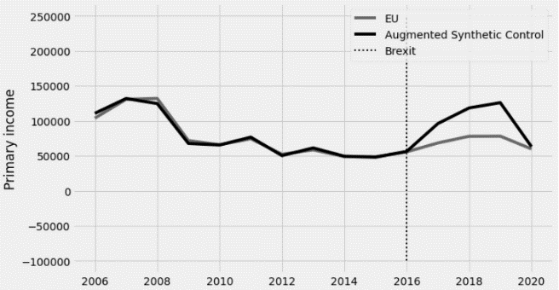

**Figure 14. Augmented Synthetic Control (Primary income)**

The credit of primary income refers to the amount of primary income obtained by the EU from the UK. In the figure above, the primary income of 2006 to 2016 is similar to ASCM. The mean square root of the measurement error during the treatment period, RMSPE, is 0.038, indicating that the error is low. This represents the EU’s primary income of ASCM from the UK.

|  |  |  |  |
| --- | --- | --- | --- |
| Table 5.Brexit's impact on Primary income, £ million | | | |
| **Year** | **Primary income** | **ridge ASCM** | **Primary income – ridge ASCM** |
| 2016 | 55619 | 56280.539 | -661.539 |
| 2017 | 68304 | 96017.819 | -27713.819 |
| 2018 | 77832 | 118307.382 | -40475.382 |
| 2019 | 77993 | 125848.418 | -47855.418 |
| 2020 | 59780 | 63058.052 | -3278.052 |

The difference between the actual primary income and ASCM between 2016-2020, when Brexit affects the EU, is -661.539, -27713.819, -40475.382, -47855.418, -3278.052. This shows that Brexit has largely reduced the EU's profits from the UK except for 2019 from 2016 to 2020. This can be interpreted as a decrease in financial transactions between the UK and the EU. It can be inferred that Foreign direct investment also had a negative impact on the EU.

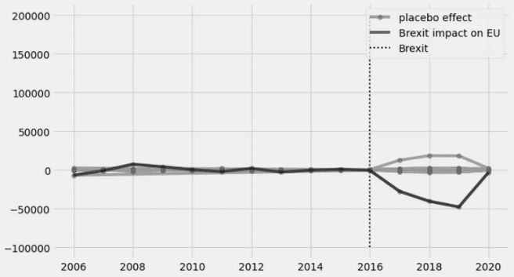

Figure 15. placebo test (Primary income)

As a result of the analysis of these changes in primary income, the placebo test in space was implemented to verify the feasibility. Figure 14 illustrates that the p-value is zero in all years from 2016 to 2020. This means that the changes in the credit of primary income since Brexit in the EU and UK have been greater than in all countries. Therefore, changes in Brexit's EU and UK's primary entry are significant.

**5.1.6 Secondary income (Credit)**

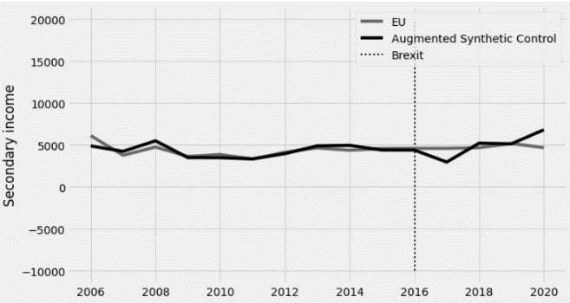

Figure 16. Augmented Synthetic Control (Secondary income)

Secondary income refers to the amount of Secondary income obtained by the EU from the UK. In the figure above, the Secondary income of 2006 to 2016 is similar to ASCM. The mean square root of the measurement error during the treatment period, RMSPE, is 0.0378, indicating that the error is low. This represents the secondary income of ASCM from the UK to the EU.

|  |  |  |  |
| --- | --- | --- | --- |
| Table 5.Brexit's impact on Secondary income, £ million | | | |
| **Year** | **Secondary income** | **ridge ASCM** | **Secondary income – ridge ASCM** |
| 2016 | 4599 | 4388.538 | 210.461 |
| 2017 | 4597 | 2962.589 | 1634.410 |
| 2018 | 4675 | 5209.738 | -534.738 |
| 2019 | 5169 | 5136.117 | 32.882 |
| 2020 | 4675 | 6805.324 | -2130.324 |

The difference between the actual Secondary income and ASCM between 2016-2020, when

Brexit affects the EU, is 210.461, 1634.410, -534.738, 32.882, -2130.324. This shows that Brexit has largely reduced UK's profits from the EU except for 2019 from 2016 to 2020. This can be interpreted as a decrease in financial transactions between the UK and the EU. It can be inferred that Brexit had a negative impact on the secondary income of the EU.

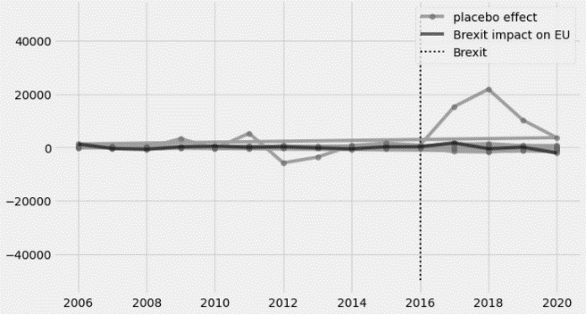

Figure 17. placebo test (Secondary income) p-value: 0.375, 0.125, 0.875, 0.125

As a result of the analysis of these secondary income changes, the placebo test in space was implemented to verify the feasibility. Figure 18 shows that the p-value is way over 0.05 in all years from 2016 to 2020. This means that the change in exports of goods and services since Brexit in the EU and UK is smaller than in all countries. Therefore, the changes in the EU's secondary income are meaningless.

**5.2 Limiting donor pool**

The correlation between the number of samples and the goodness of fit was found in Appendix B, which identified whether multiple samples were required or not. Almost all of the samples were found to have dropped a lot of goodness of fitting from removing more than two countries. Current Account has lost a lot of goodness of fitting since it removed more than two countries out of eight countries. The Export of Goods was able to identify a significant drop in the goodness of fitting by excluding more than four countries. The Export of Service was able to confirm that goodness of fitting was OK even if it had ruled out the whole sample country. Total exports of goods and services showed that goodness of fitting decreased after removing more than three countries. The goodness of fitting has decreased since the removal of more than three primary countries. Secondary income showed that goodness of fitting decreased after removing more than three countries. In summary, the selection of multiple samples through the above method has generally been shown to have important correlations in the goodness of fitting. And the number of countries in the sample must be at least 5-6 so that goodness of fitting can make a decent ASCM. As a result, it is shown that extracting multiple samples was necessary and that selecting a small number of samples to obtain ASCM is unsuitable for this study.  
 In Appendix B we were able to further ascertain whether the Brexit outcome was altered by changing control groups or not. If the results are the same as when the entire sample is selected, the existing results can be determined to be significant. If the results are different, this means that the results vary depending on the country selected as the sample, so it can be judged that the results are not significant.  
 The results of the Limiting Donor pool for each variable are as follows. The Current Account (CA) was first checked. The actual CA value in the overall figure is greater than ASCM. Therefore, it can be judged that the results are significant. Exports of goods from the UK to the EU all showed that the actual value of export of goods was less than ASCM. The results were therefore significant. Exports of services from the UK to the EU show that ASCM is higher than actual exports of services even when all countries are removed from the sample. Export of goods and services were all consistent except when China was removed. The results of the primary income study were consistent except when the china was removed from the sample. The results about secondary income were inconsistent. The more sample countries are excluded, the more different the results are. We can therefore see that the results of secondary income are not significant.

**5.3 Hypothesis testing**

Overall, the results are considered and the hypothesizes are tested as follows.

***5.3.1 Hypothesis 1 testing***  
UK's current account with EU < ASCM   
(= UK's current account with the EU has been reduced by Brexit.)

In hypothesis 1, the null hypothesis is that the CA has been raised due to Brexit. This was hypothesized because the mean of the CA increased after Brexit. Unlike what was seen, CA was larger than ASCM. So hypothesis 1 was rejected. The placebo test and the controller pool test confirmed that the results were significant.

***5.3.2 Hypothesis 2 testing***  
UK's export of goods to EU > ASCM  
(= The UK's export of goods to the EU with the EU has increased due to Brexit.)

In hypothesis 2, the null hypothesis is that the UK's export of goods to the EU decreased due to Brexit. This was hypothesized because the UK's export of goods to the EU mean fell after Brexit. Unlike what was seen, the UK's export of goods to the EU was smaller than ASCM. So hypothesis 1 was rejected. The placebo test and the controller pool test confirmed that the results were significant.

***5.3.3 Hypothesis 3 testing***  
UK's export of services to EU > ASCM   
(= The UK's export of services to the EU has increased by Brexit.)

In hypothesis 3, the null hypothesis is that the UK's export of services to the EU decreased due to Brexit. This was hypothesized because the UK's export of goods to the EU mean fell after Brexit. Unlike what was seen, the UK's export of services to the EU was smaller than ASCM. So hypothesis 3 was rejected. The placebo test and the controller pool test confirmed that the results were significant.

***5.3.4 Hypothesis 4 testing***  
UK's export of goods and services to EU > ASCM   
(= The UK's export of goods and services to the EU has increased by Brexit.)

In hypothesis 4, the null hypothesis is that the UK's export of services to the EU decreased due to Brexit. This was hypothesized because the UK's export of goods to the EU average fell after Brexit. Unlike what was seen, the UK's export of services to the EU was smaller than ASCM. So hypothesis 4 was rejected. The placebo test and the controller pool test confirmed that the results were significant.

***5.3.5 Hypothesis 5 testing***  
The credit of primary income for the EU in the UK > ASCM   
(= The UK's export of goods and services to the EU has increased by Brexit.)

In hypothesis 5, the null hypothesis is that the credit of primary income for the EU in the UK has been lowered due to Brexit. This was hypothesized because the credit of primary income for the EU in the UK was dropped after Brexit. Unlike the phenomenon shown, the credit of primary income for the EU in the UK was smaller than ASCM. So hypothesis 5 was rejected. The placebo test and the controller pool test confirmed that the results were significant.

***5.3.6 Hypothesis 6 testing***  
The credit of secondary income for the EU in the UK > ASCM

(= The credit of secondary income for the EU in the UK has increased by Brexit.)

In hypothesis 6, the null hypothesis is that the credit of secondary income for the EU in the UK has been lowered due to Brexit. The credit of secondary income for the EU in the UK is hypothesized because the mean has fallen since Brexit. Unlike the phenomenon shown, the credit of secondary income for the EU in the UK was smaller than ASCM. However, hypothesis 6 was not rejected. The results in the placebo test and the controller pool test were not significant.

**6. Discussion**

**6.1 Interpretation of the results**

The result of the analysis showed that Brexit lowered the EU's current account (CA) with the UK. And the results came out to be significant. This result implies the overall effect of Brexit on the EU was negative.

Figure 18. UK’s Export of goods (2020)

The UK’s export of goods to the EU has increased after the Brexit. The main exports of goods were Finished manufactured goods and unspecified goods. Finished goods tend to be affected by the price which is dependent on tariffs. It is assumed that tariffs are likely to be changed in both countries not in one country only. Since there was no actual change between 2016 and 2020, it was assumed that people's expectations were reflected in the change. It can therefore be thought that there was little expectation that trade changes such as tariffs would be large.

Figure 19. UK’s Export of services (2020)

Service exports from the UK to the EU fell further due to Brexit. According to figure 20, the financial service takes the largest proportion in the 2020 year, which implies that the decrease of export of service can be much explained with the financial service sector. The reason for financial service export decrease could be that people do not want to deal with the EU or the UK because of the uncertainty caused by Brexit.

Figure 20. UK’s export of goods and services (2020)

The total export of goods and services to EU has decreased by Brexit. According to figure 21, the proportion of goods export is similar to that of service export. This means that Brexit’s impacts on the Export of goods and Export of Service were similar.

Figure 21. the credit of primary income (2020)

Figure 22. UK’s investment income credit (2020)

According to results, Brexit reduced the primary income the EU receives from the UK. Figure 22 shows that investment income takes the largest proportion. Additionally, it can be seen that investment income is highly related to FDI from figure 23. Therefore it can be concluded that Brexit has reduced revenue from FDI in the EU.

A reduction in Foreign Direct investment means a reduction in business to the EU. This result is in line with the negative impact of financial services from Brexit. In other words, Brexit has dampened the financial sector.

Figure 23. The credit of secondary income (2020)

Figure 24. Other sectors (2020)

Secondary income turned out not to be significantly affected by Brexit. The reason for this no change can be inferred from the graph above. Figure 24 and figure 25 show that secondary income consists mostly of other receipts.

Other receipts are dividends, rebates, candidate’s funds, interest, and other funds from the candidate committee or noncandidate committee. But this does not include contributions from others or loans. In other words, other receipts are sources of income from own financial activities.

The reason for the insignificant result could be that Brexit was considered not enough to change most laws related to other receipts. This could because there are many ways to gain other receipts, so Brexit might not be considered as influential.

**7. Conclusion**

We examined the economic parameters between the UK and the EU to determine the impact of Brexit on the relationship between the UK and the EU. Selected dependent variables are UK's current account with EU, export of goods UK to EU, export of service from the UK to EU, export of goods and services the UK to EU, the credit of primary income with EU in the UK, and the credit of secondary income with EU in the UK. Using the Augmented Synthetic Control method, we created a counterfactual world. This method identified how the selected variables would have moved without the Brexit referendum.

There were predictions that Brexit would have negative consequences on the EU, which is generally correct. Mostly, the trade between the EU and UK has become worse because of Brexit concerning the EU. The Current account of the UK with the EU has increased because of Brexit, which means the CA of the EU with the UK has decreased. The UK’s export of goods to the EU has increased. The UK’s export of services to the EU and the UK’s export of goods and services to EU has decreased. The credit of primary income with the EU has decreased. Lastly, the credit of secondary income with the EU has decreased. Finally, we apply placebo test and limitation of donor pool to check for the robust analysis. It has been found that all the dependent variable’s changes except that of secondary variable were significant.

There was a little doubt that the Brexit deal might not have any impact on the EU economy. Because the deals have not been fully settled, it was thought that Brexit might not be influential. Now it is certified that the negative predictions of EU economies are significant. With well-developed quantitative analysis techniques, this paper contributed to current literature, in which Brexit influences economic exchanges at the national level between UK and EU.

However, there are still unresolved issues because of the unpredictable future. It is still unexpected how the Brexit deal would be ended. Because there has not been much change in the law, it is likely that the change from the 2016 year has been derived from people’s expectation. Therefore it is necessary to do this research again after the Brexit deal has been fully settled and continued

Reference

Abadie, A., & Gardeazabal, J. (2003). The economic costs of conflict: A case study of the Basque Country. *American economic review*, *93*(1), 113-132.Abadie, A., Diamond, A., & Hainmueller, J. (2010). Synthetic control methods for comparative case studies: Estimating the effect of California’s tobacco control program. *Journal of the American statistical Association*, *105*(490), 493-505.

Abadie, A., Diamond, A., & Hainmueller, J. (2015). Comparative politics and the synthetic control method. *American Journal of Political Science*, *59*(2), 495-510.

Ahir, A., & James, K. R. (2021). Rebooting UK Financial Regulation for a Post-Brexit World-A Conference Summary. *LSE Law-Policy Briefing Paper*, (46).

Abadie, A., & L’hour, J. (2019). A penalized synthetic control estimator for disaggregated data. *Preliminary and incomplete*.

Alcalá, F., & Ciccone, A. (2004). Trade and productivity. *The Quarterly journal of economics*, *119*(2), 613-646.

Aust, V., Morais, A. I., & Pinto, I. (2020). How does foreign direct investment contribute to Sustainable Development Goals? Evidence from African countries. *Journal of Cleaner Production*, *245*, 118823.

Ben-Michael, E., Feller, A., & Rothstein, J. (2021). The augmented synthetic control method. *Journal of the American Statistical Association*, (just-accepted), 1-34.

Burke, A. (2000). Ultracapacitors: why, how, and where is the technology. *Journal of power sources*, *91*(1), 37-50.

Breidt, F. J., & Opsomer, J. D. (2017). Model-assisted survey estimation with modern prediction techniques. *Statistical Science*, *32*(2), 190-205.

Cahuc, P., Carcillo, S., & Zylberberg, A. (2014). *Labor economics*. MIT press.

Cho, Y., & Newhouse, D. (2011). *How did the great recession affect different types of workers? Evidence from 17 middle-income countries*. The World Bank.

Collins, D. A. (2021). Foreign Investment under the UK-EU Trade and Cooperation Agreement: Mitigating Punctuated Equilibrium in Legal Economic Dis-Integration. *Manchester Journal of International Economic Law*, *18*(1), 50-69.

Contractor, F. J., Dangol, R., Nuruzzaman, N., & Raghunath, S. (2020). How do country regulations and business environment impact foreign direct investment (FDI) inflows?. *International Business Review*, *29*(2), 101640.

Corrado, C., Hulten, C., & Sichel, D. (2009). Intangible capital and US economic growth. *Review of income and wealth*, *55*(3), 661-685.

Deville, J. C., Särndal, C. E., & Sautory, O. (1993). Generalized raking procedures in survey sampling. *Journal of the American statistical Association*, *88*(423), 1013-1020.

Doudchenko, N., & Imbens, G. W. (2016). *Balancing, regression, difference-in-differences and synthetic control methods: A synthesis* (No. w22791). National Bureau of Economic Research.

Keating, M. (2021). Taking back control? Brexit and the territorial constitution of the United Kingdom. *Journal of European Public Policy*, 1-19.

King, G., Keohane, R. O., & Verba, S. (1994). *Designing social inquiry: Scientific inference in qualitative research*. Princeton university press.

Geddes, B. (2003). *Paradigms and sand castles: Theory building and research design in comparative politics*. University of Michigan Press.

George, A. L., & Bennett, A. (2005). Case studies and theory development in the social sciences Cambridge.

Groysberg, B., Lee, L. E., & Nanda, A. (2008). Can they take it with them? The portability of star knowledge workers' performance. *Management Science*, *54*(7), 1213-1230.

James, S., & Quaglia, L. (2020). *The UK and Multi-Level Financial Regulation: From Post-Crisis Reform to Brexit*. Oxford University Press.

Johnson, H. G. (1953). Optimum tariffs and retaliation. *The Review of Economic Studies*, *21*(2), 142-153.

Hartley, K., van Santen, R., & Kirchherr, J. (2020). Policies for transitioning towards a circular economy: Expectations from the European Union (EU). *Resources, Conservation and Recycling*, *155*, 104634.

Heneghan, M., & Hall, S. (2020). The emerging geography of European financial centres: Fragmentation in the European Union and concentration in the UK?. *European Urban and Regional Studies*, 0969776420975817.

Hix, S. (2018). Brexit: where is the EU–UK relationship heading?. *Journal of Common Market Studies*.

Hodson, D. (2010). The EU economy: The euro area in 2009. *J. Common Mkt. Stud.*, *48*, 225.

Kaya, O., Schildbach, J., Lakhani, K., AG, D. B., & Schneider, S. (2018). Brexit impact on investment banking in Europe. *Deutsche Bank Research, EU Monitor*.

Kirkegaard, J. F. (2020). Chinese Investment in the US and the EU is Declining–for Similar Reasons. *China & World Economy*, *28*(2), 59-83.

Macinko, J., Starfield, B., & Shi, L. (2003). The contribution of primary care systems to health outcomes within Organization for Economic Cooperation and Development (OECD) countries, 1970–1998. *Health services research*, *38*(3), 831-865.

Marquardt, D. W., & Snee, R. D. (1975). Ridge regression in practice. *The American Statistician*, *29*(1), 3-20.

McCombie, J., & Thirlwall, A. P. (2016). *Economic growth and the balance-of-payments constraint*. Springer.

Mallet-García, M. L., & García-Bedolla, L. (2021). Immigration Policy and Belonging: Ramifications for DACA Recipients’ Sense of Belonging. *American Behavioral Scientist*, 0002764221996777.

Marshall, A. (2015). *Industry and trade*. Vani Prakashan.

McCarthy, J., & Wright, P. (2004). Technology as experience. *interactions*, *11*(5), 42-43.

Mineo, C., Pierce, S. G., Nicholson, P. I., & Cooper, I. (2016). Robotic path planning for non-destructive testing–A custom MATLAB toolbox approach. *Robotics and Computer-Integrated Manufacturing*, *37*, 1-12.

Morvan, A. S. (2021). Open Finance: EU & UK on the Same Path, What About Standards?. *AGEFI Luxembourg, Forthcoming*.

Larson, P. D., & Halldorsson, A. (2002). What is SCM? And, where is it?. *Journal of Supply Chain Management*, *38*(3), 36-44.

Levin, H. M., & McEwan, P. J. (2000). *Cost-effectiveness analysis: Methods and applications* (Vol. 4). Sage.

Lundvall, B. Ä., & Johnson, B. (1994). The learning economy. *Journal of industry studies*, *1*(2), 23-42.

O'rourke, K. H. (2000). Tariffs and growth in the late 19th century. *The Economic Journal*, *110*(463), 456-483.

Pain, N., & Young, G. (2004). The macroeconomic impact of UK withdrawal from the EU. *Economic modelling*, *21*(3), 387-408.

Pandzic, L. (2021). IMPACT OF BREXIT ON UK-EU TRADE RELATIONSHIP. *Ecoforum Journal*, *10*(1).

Paul, J., & Feliciano-Cestero, M. M. (2021). Five decades of research on foreign direct investment by MNEs: An overview and research agenda. *Journal of business research*, *124*, 800-812.

Robbins, M. W., Saunders, J., & Kilmer, B. (2017). A framework for synthetic control methods with high-dimensional, micro-level data: evaluating a neighborhood-specific crime intervention. *Journal of the American Statistical Association*, *112*(517), 109-126.

Tetlow, G., & Stojanovic, A. (2018). Understanding the economic impact of Brexit. *Institute for government*, 2-76.

Wang, L., & Li, Y. (2021). The negotiation of EU–China comprehensive agreement on investment and its potential impact in the post-pandemic era. *Journal of Chinese Economic and Business Studies*, 1-8.

Weber, M. (2019). *Economy and society*. Harvard University Press.

Shleifer, A. (2005). Understanding regulation. *European Financial Management*, *11*(4), 439-451.

Syverson, C. (2011). What determines productivity?. *Journal of Economic literature*, *49*(2), 326-65.

Van Kerckhoven, S. (2021). Post-Brexit leadership in European finance. *Politics and Governance*, *9*(1), 59-68.

Data source

Eurostat (2021), foreign direct investments (FDI). Retrieved from : https://ec.europa.eu/eurostat/web/economic-globalisation/globalisation-in-business-statistics/foreign-direct-investments

OECD (2021), Inflation (CPI) (indicator). doi: 10.1787/eee82e6e-en (Accessed on 29 June 2021)

OECD (2021), Gross domestic product (GDP) (indicator). doi: 10.1787/dc2f7aec-en (Accessed on 29 June 2021)

OECD (2021), Unemployment rate (indicator). doi: 10.1787/52570002-en (Accessed on 29 June 2021)

Saisana M. (2014) Education Index. In: Michalos A.C. (eds) Encyclopedia of Quality of Life and Well-Being Research. Springer, Dordrecht. Retrieved from https://doi.org/10.1007/978-94-007-0753-5_840

United Kingdom Economic Accounts (UKEA). 2020 ukea2020q4table8bopcurrentandcapitalaccount. [Data file]. Retrieved from UK Economic Accounts: balance of payments - financial account - Office for National Statistics (ons.gov.uk)

**Appendix. A**

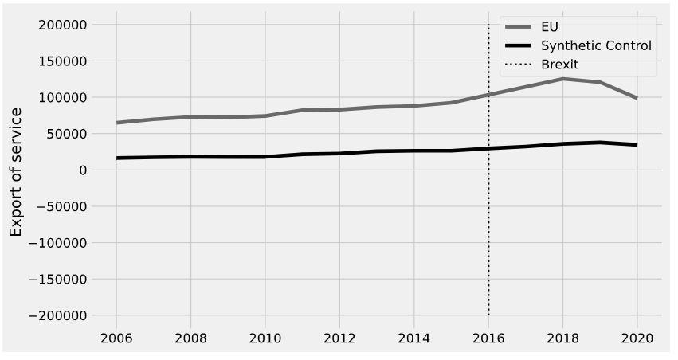

Figure 25. Application of Synthetic control method for export of service.

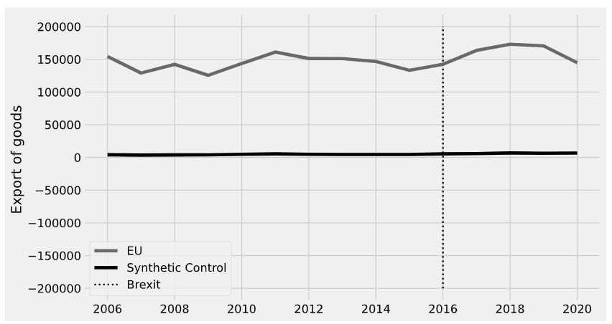

Figure 26. Application of Synthetic control method for export of goods.

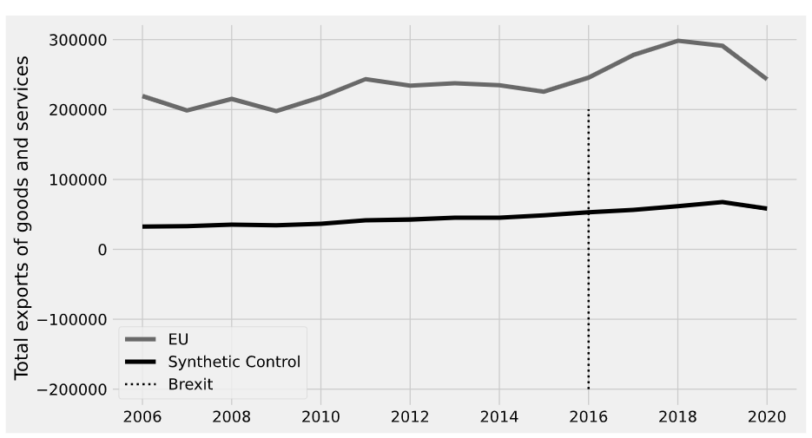

Figure 27. Application of Synthetic control method for export of goods and service.

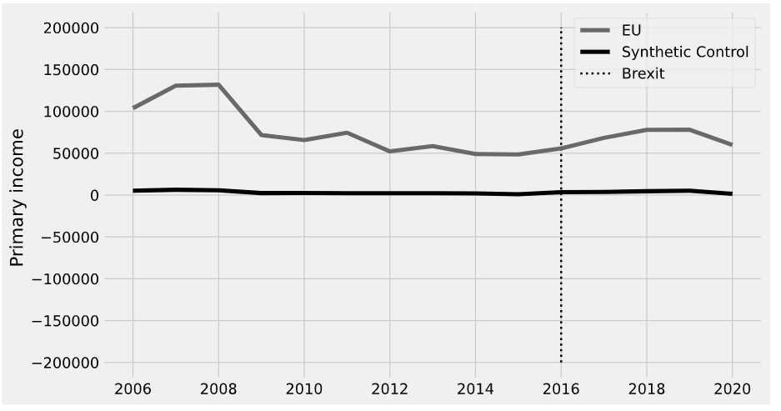

Figure 28. Application of Synthetic control method for primary income.

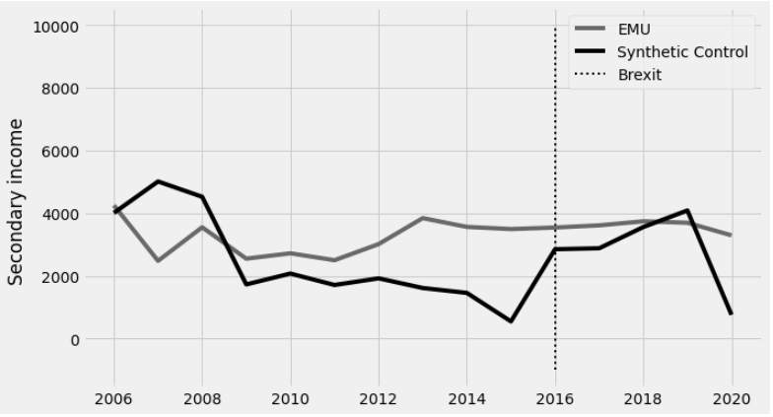

Figure 29. Application of Synthetic control method for secondary income.

Table 14. Weight of countries through Synthetic control method.

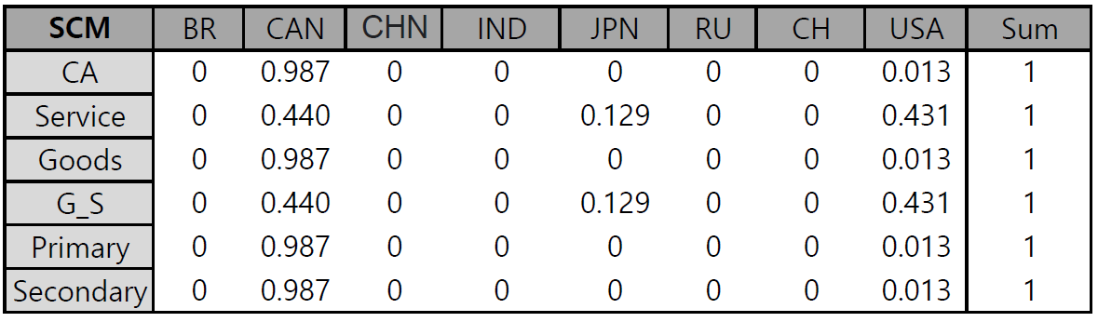

**Appendix B**

< Current account >

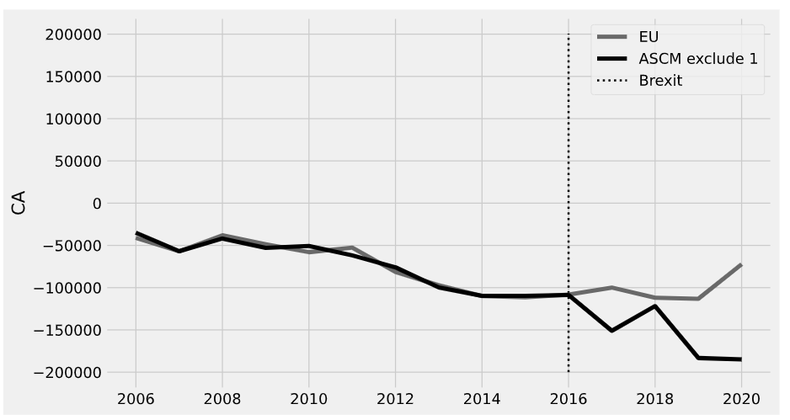

Figure . Exclude brazil

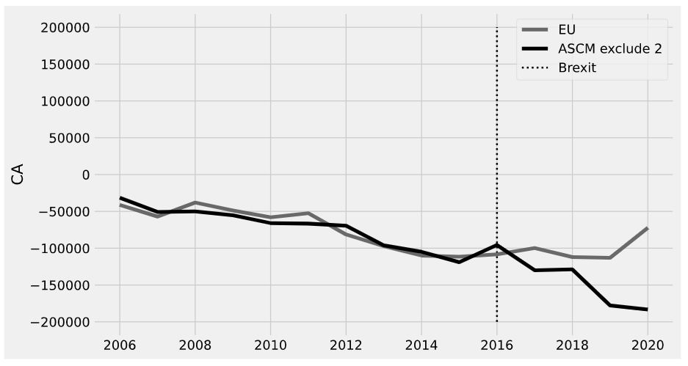

Figure . Exclude Brazil, Canada

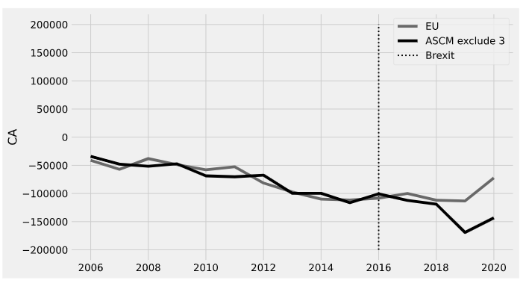

Figure . Exclude Brazil, Canada, China

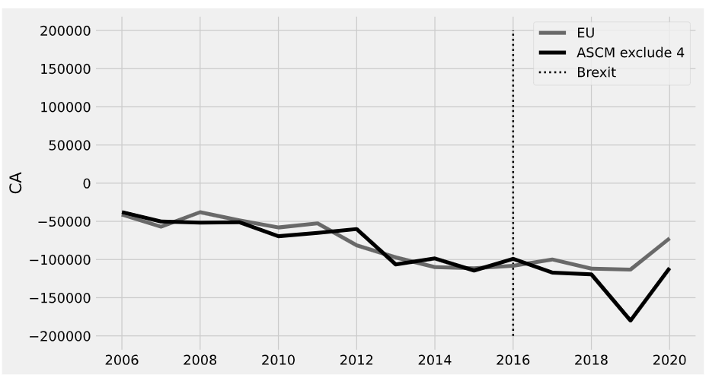

Figure . Exclude Brazil, Canada, China, India

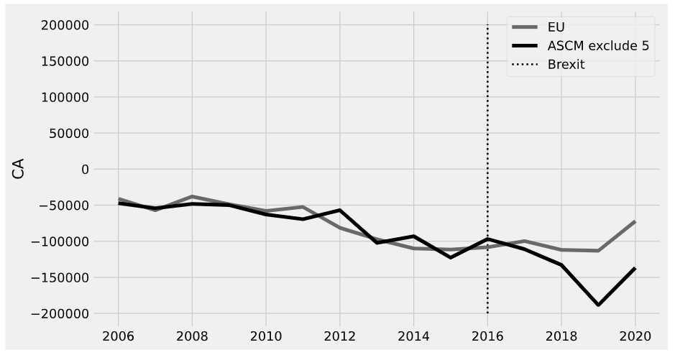

Figure . Exclude Brazil, Canada, India, Japan

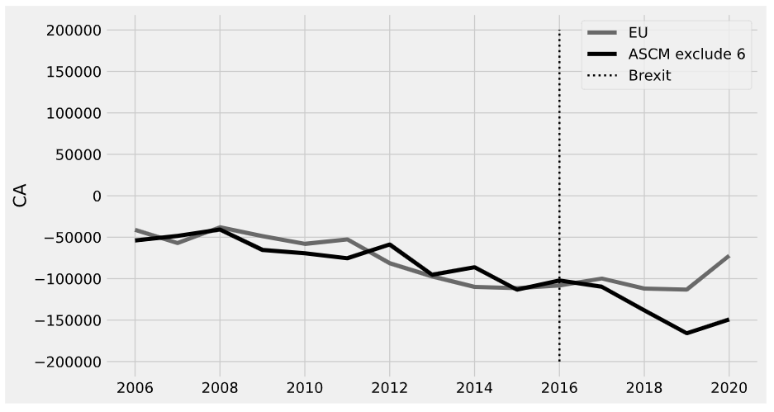

Figure . Brazil, Canada, China, India, Japan, Russia

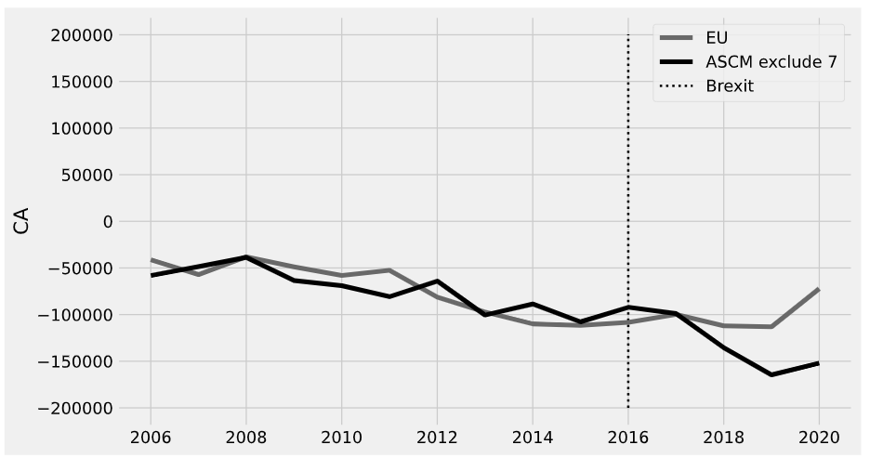

Figure . Brazil, Canada, China, India, Japan, Russia, Switzerland

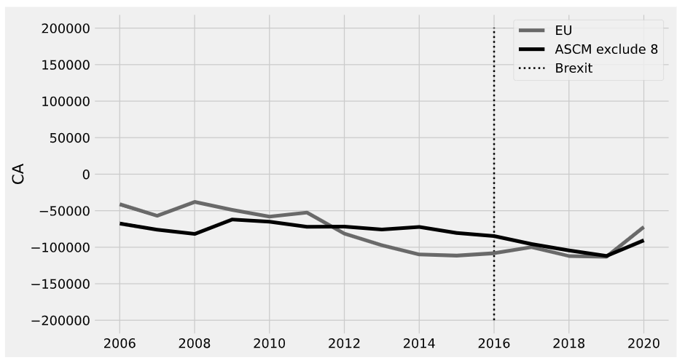

Figure . Brazil, Canada, China, India, Japan, Russia, Switzerland, USA

< Export of goods from UK to EU >

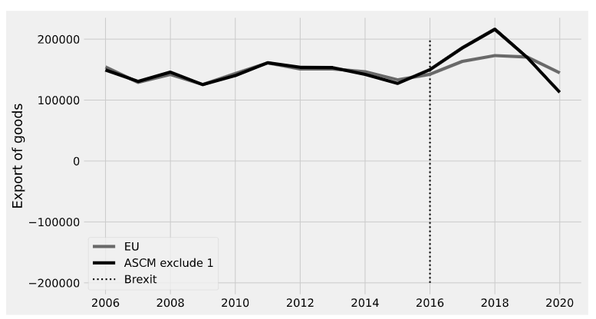

Figure . Brazil

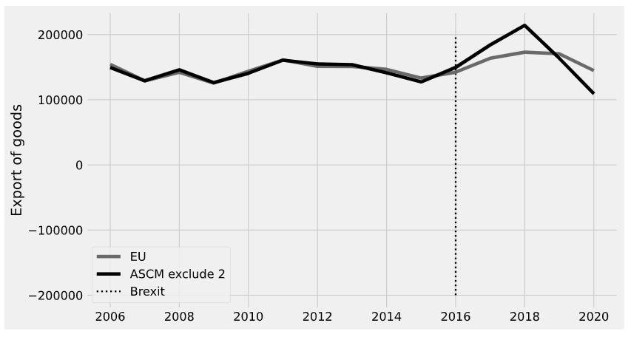

Figure . Brazil, Canada

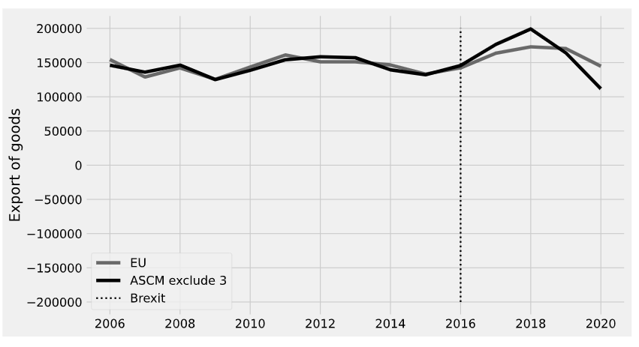

Figure . Brazil, Canada, China

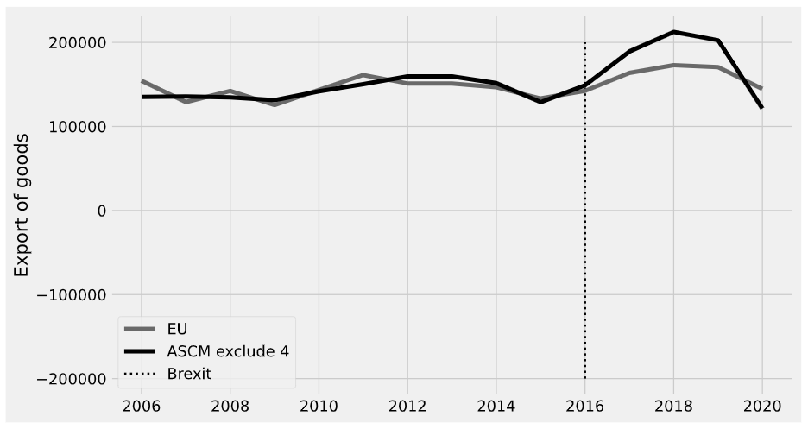

Figure . Brazil, Canada, China, India

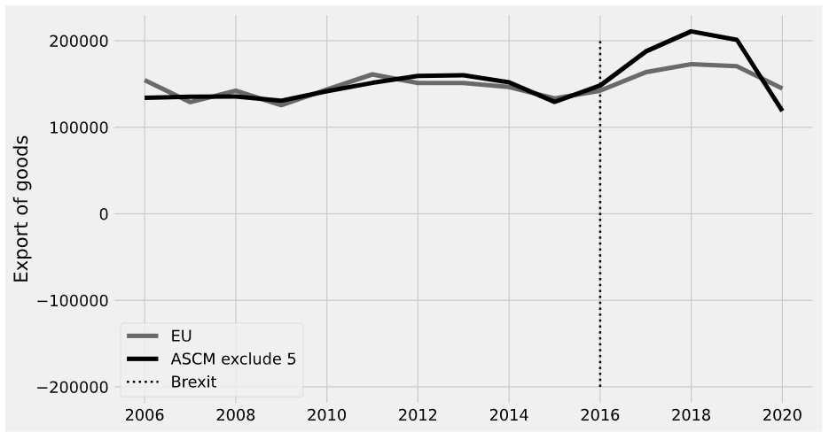

Figure . Brazil, Canada, China, India, Japan

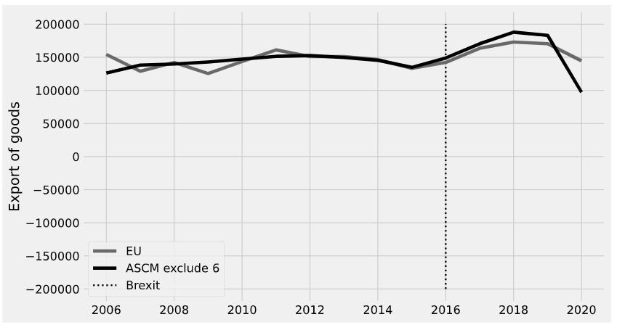

Figure . Brazil, Canada, China, India, Japan, Russia

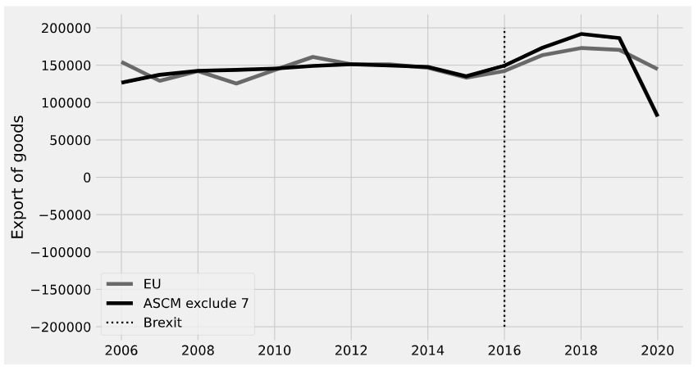

Figure . Brazil, Canada, China, India, Japan, Russia, Switzerland

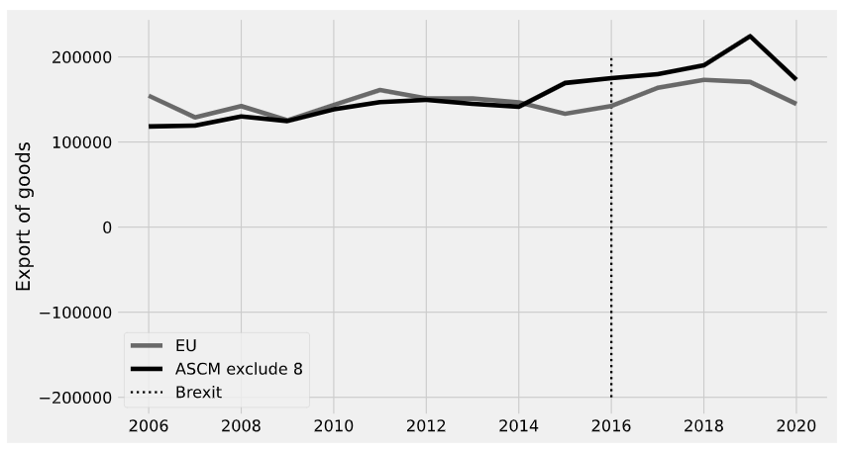

Figure . Brazil, Canada, China, India, Japan, Russia, Switzerland, USA

< Export of services from UK to EU >

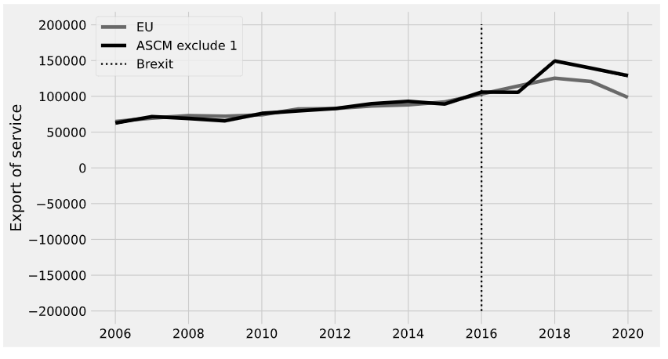

Figure . Brazil

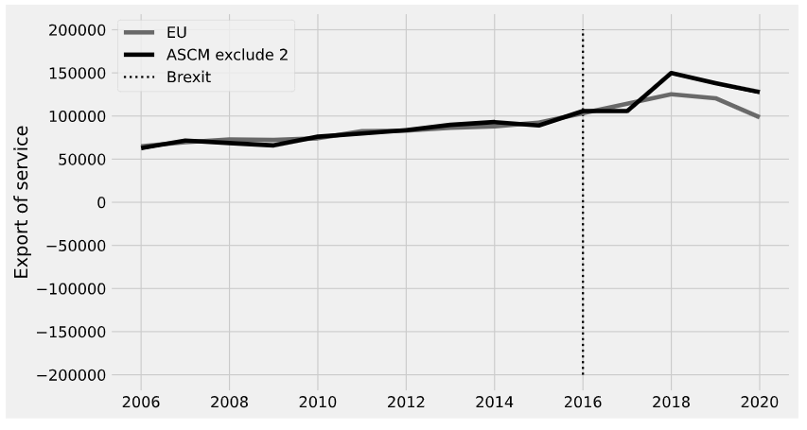

Figure . Brazil, Canada

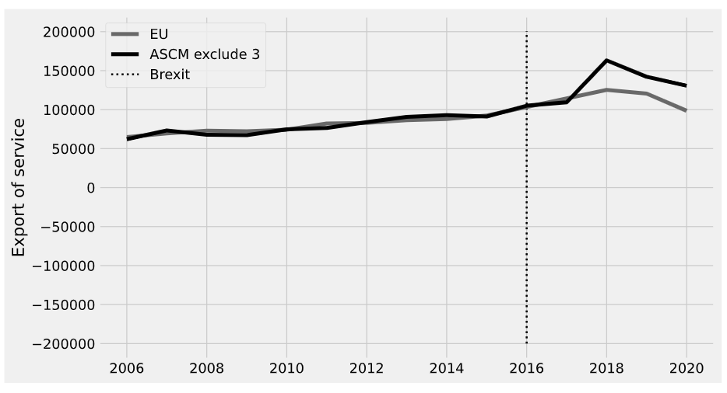

Figure . Brazil, Canada, China

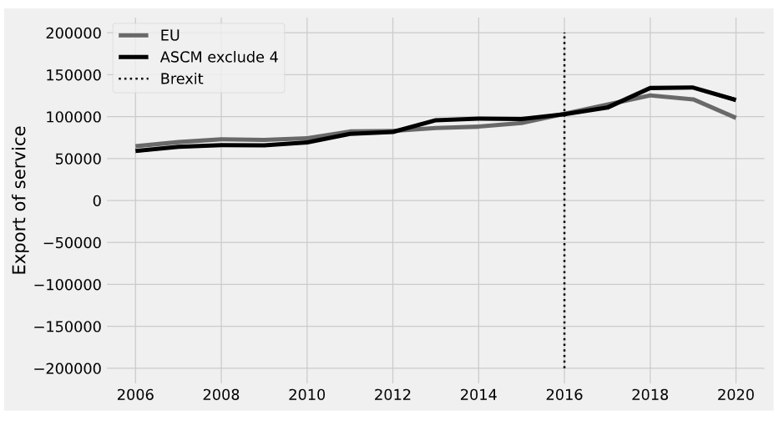

Figure . Brazil, Canada, China, India

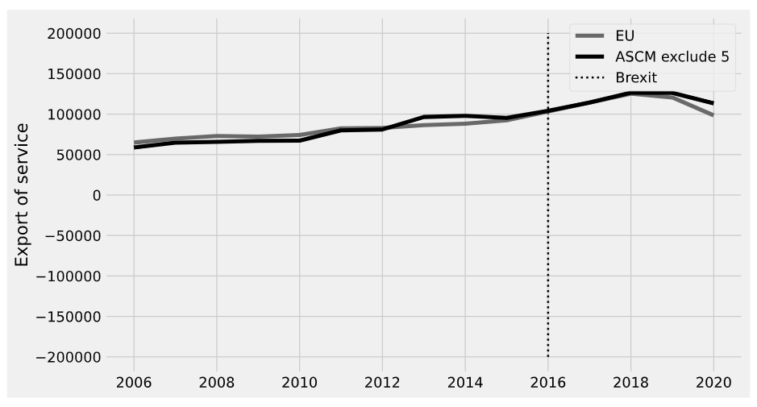

Figure . Brazil, Canada, China, India, Japan

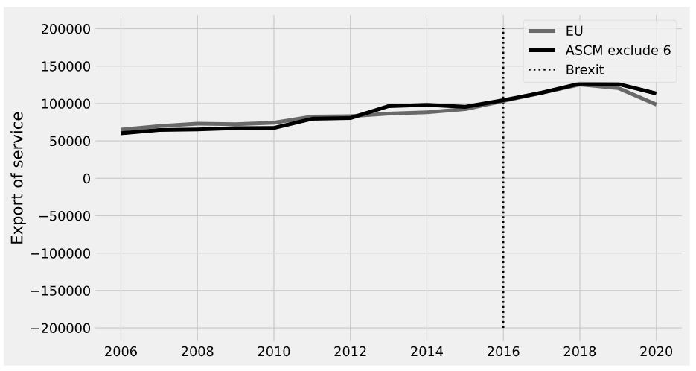

Figure . Brazil, Canada, China, India, Japan, Russia

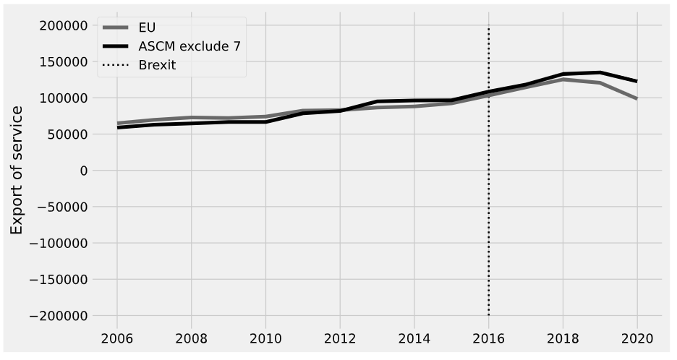

Figure . Brazil, Canada, China, India, Japan, Russia, Switzerland

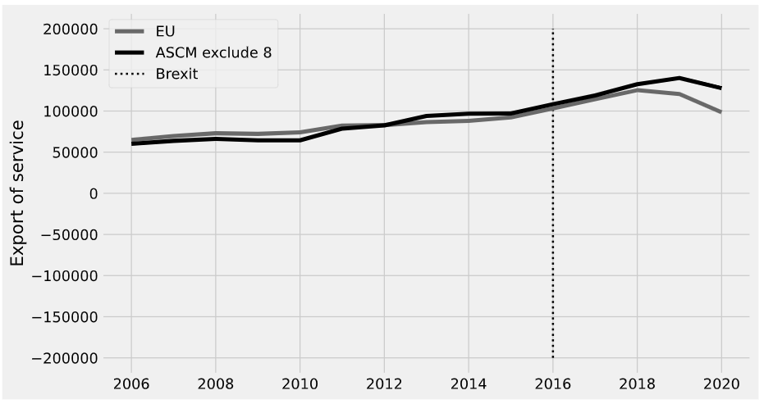

Figure . Brazil, Canada, China, India, Japan, Russia, Switzerland, USA

< Export of goods and services from UK to EU >

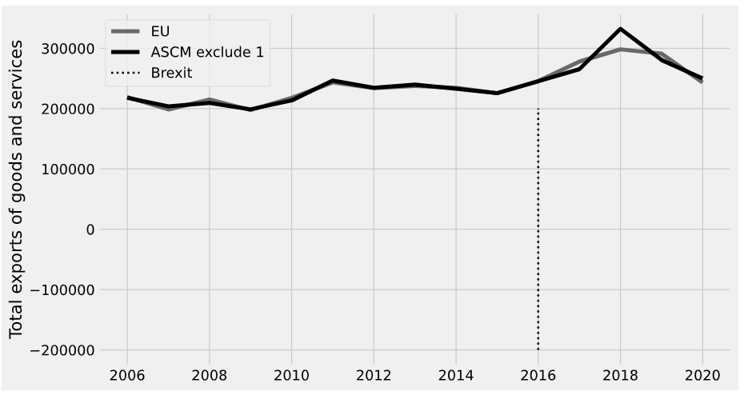

Figure . Brazil

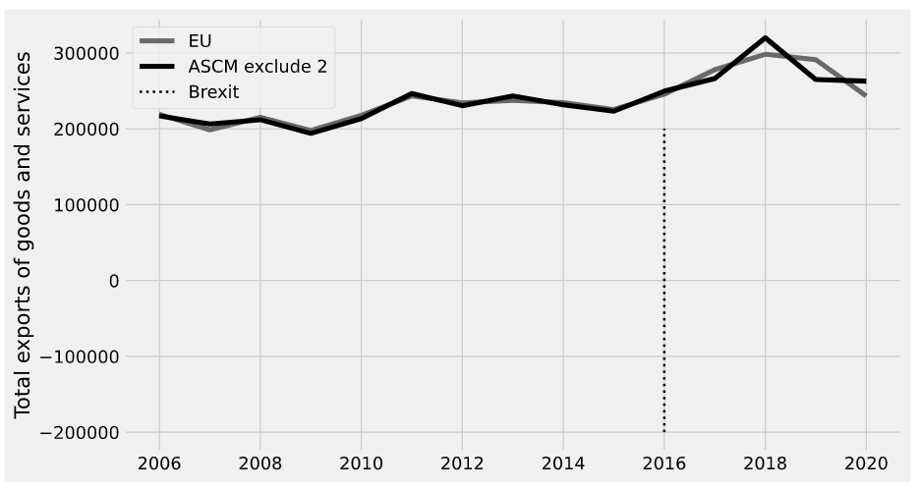

Figure . Brazil, Canada

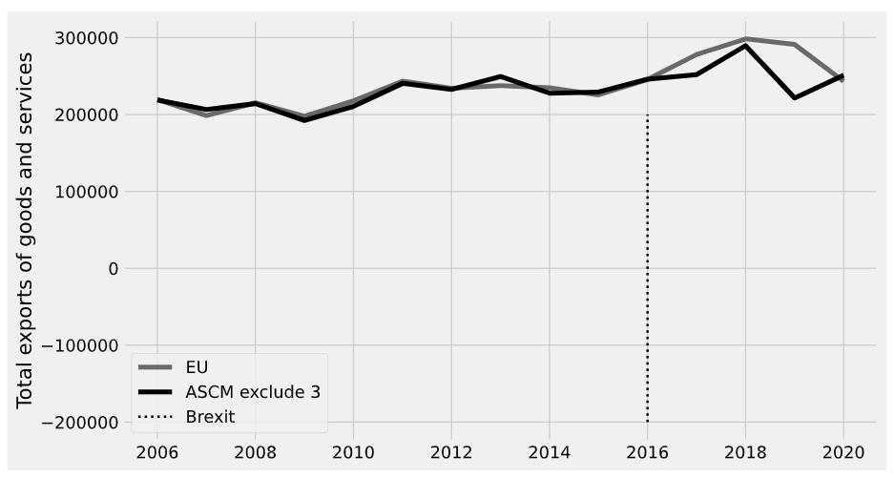

Figure . Brazil, Canada, China

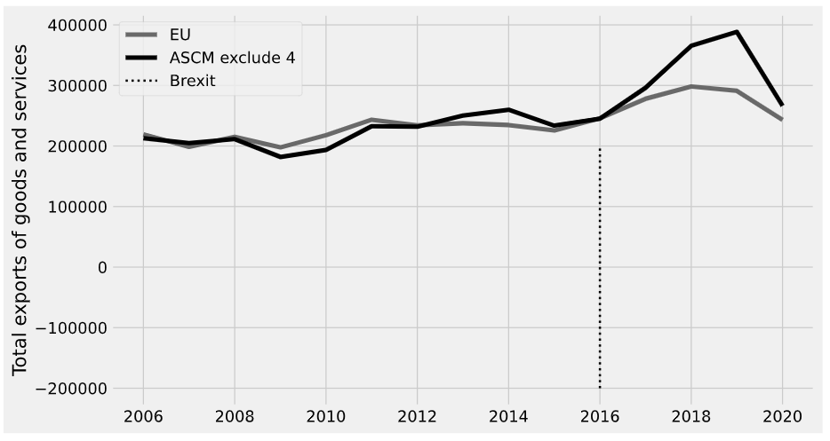

Figure . Brazil, Canada, China, India

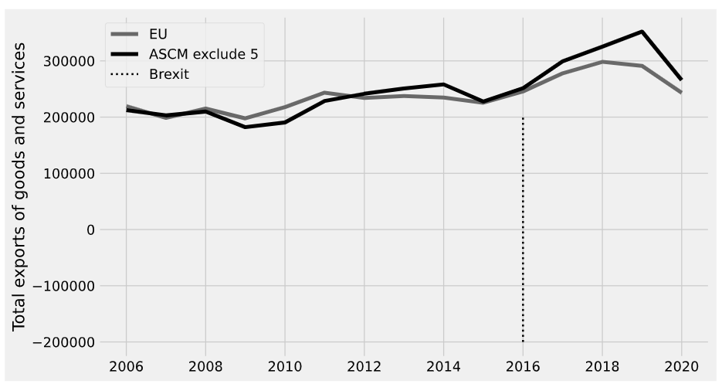

Figure . Brazil, Canada, China, India, Japan

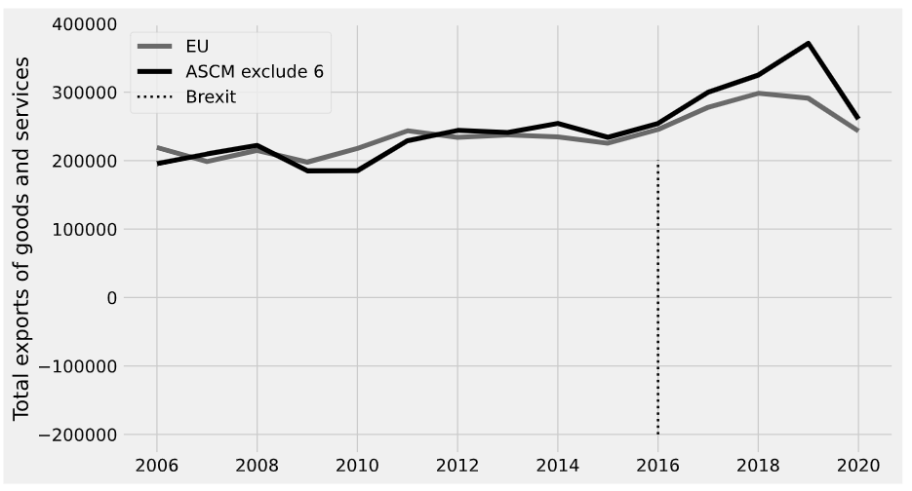

Figure . Brazil, Canada, China, India, Japan, Russia

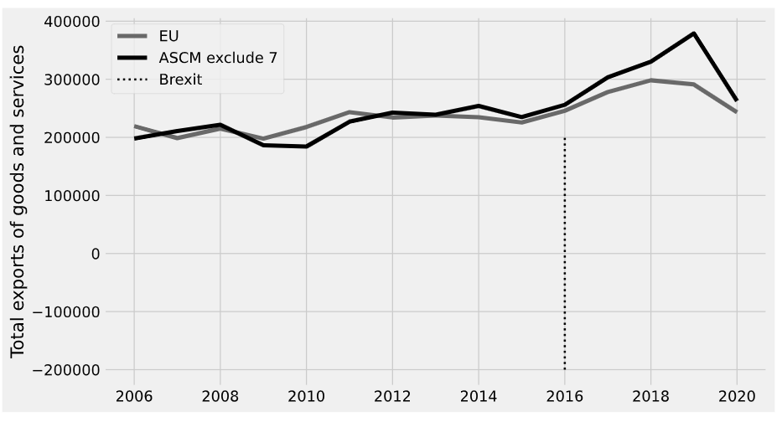

Figure . Brazil, Canada, China, India, Japan, Russia, Switzerland

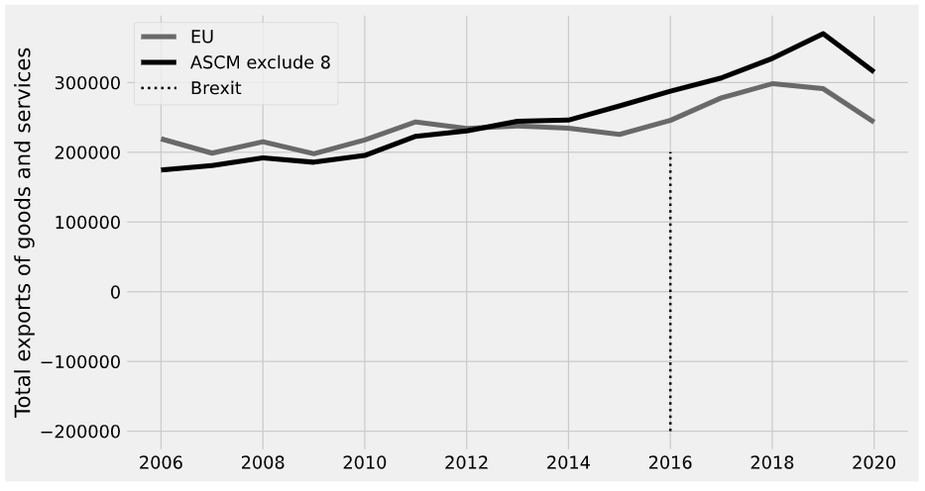

Figure . Brazil, Canada, China, India, Japan, Russia, Switzerland, USA

< The credit of primary income of EU in the UK >

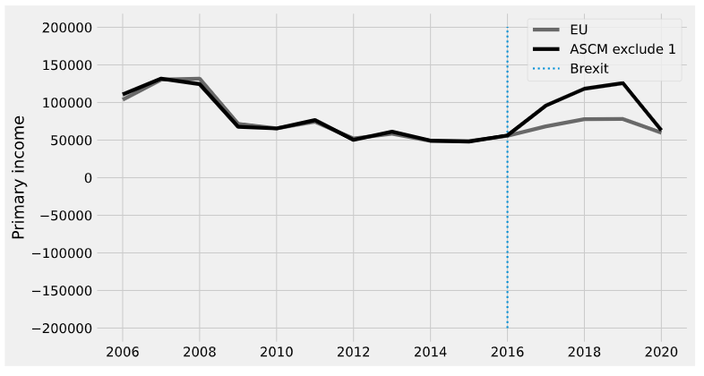

Figure . Brazil

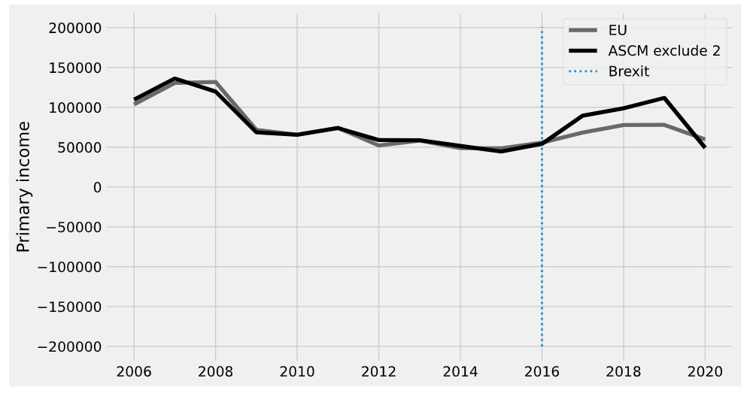

Figure . Brazil, Canada

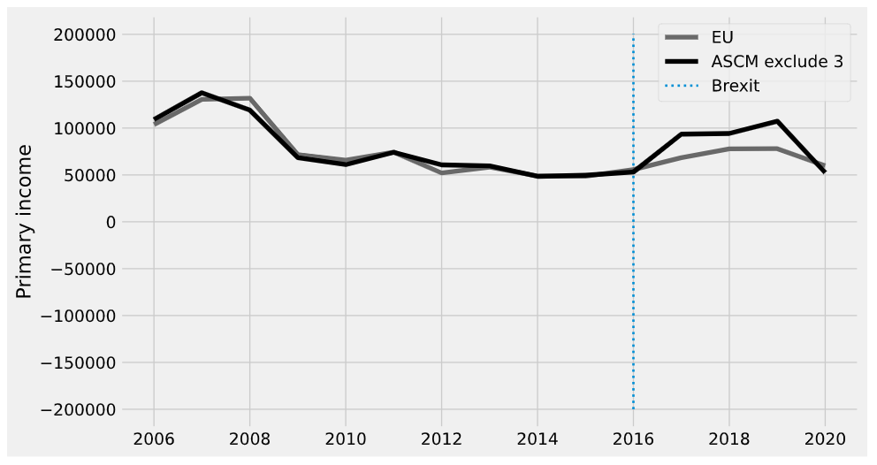

Figure . Brazil, Canada, China

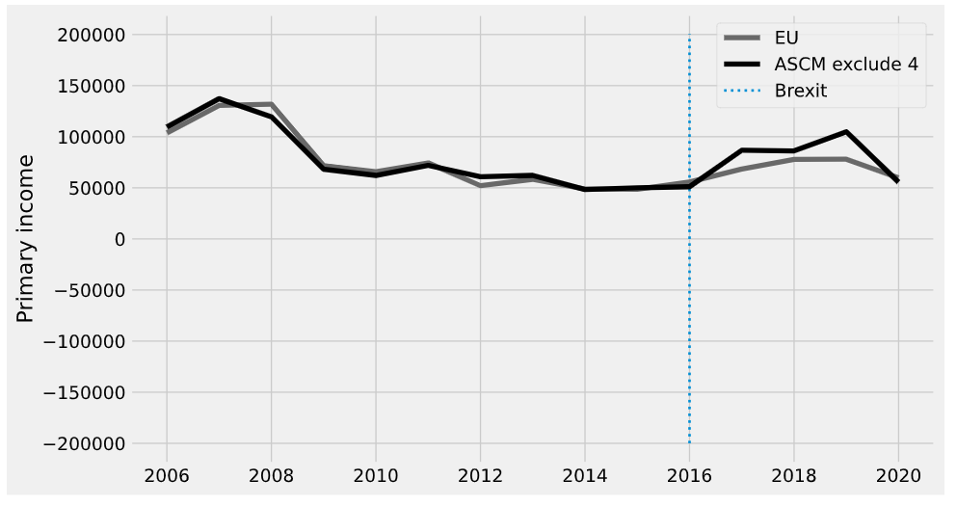

Figure . Brazil, Canada, China, India

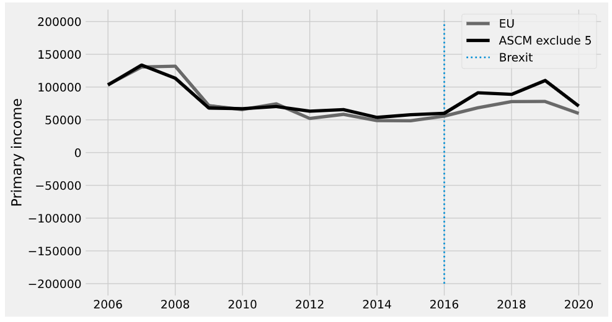

Figure . Brazil, Canada, China, India, Japan

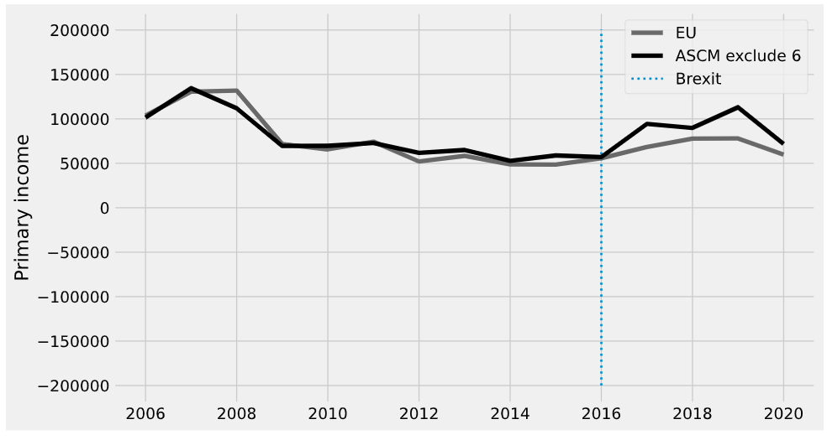

Figure . Brazil, Canada, China, India, Japan, Russia

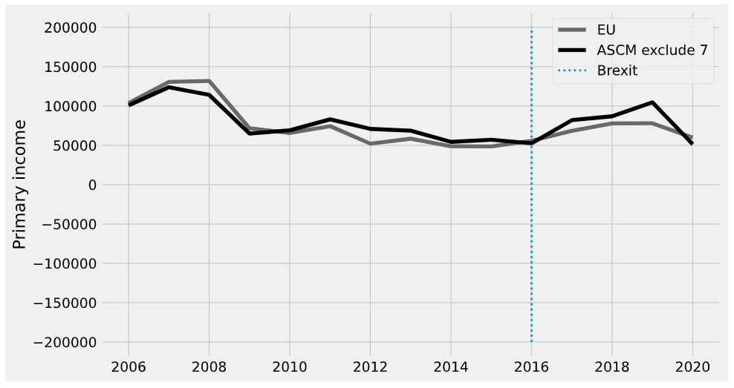

Figure . Brazil, Canada, China, India, Japan, Russia, Switzerland

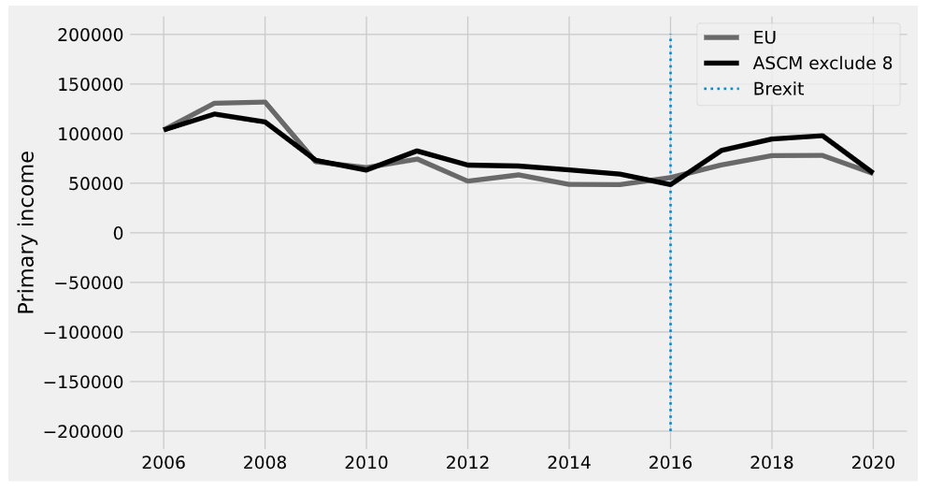

Figure . Brazil, Canada, China, India, Japan, Russia, Switzerland, USA

< The credit of secondary income of EU in the UK >

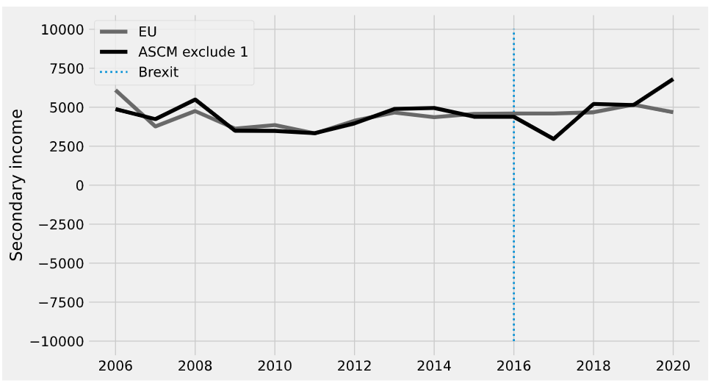

Figure . Brazil

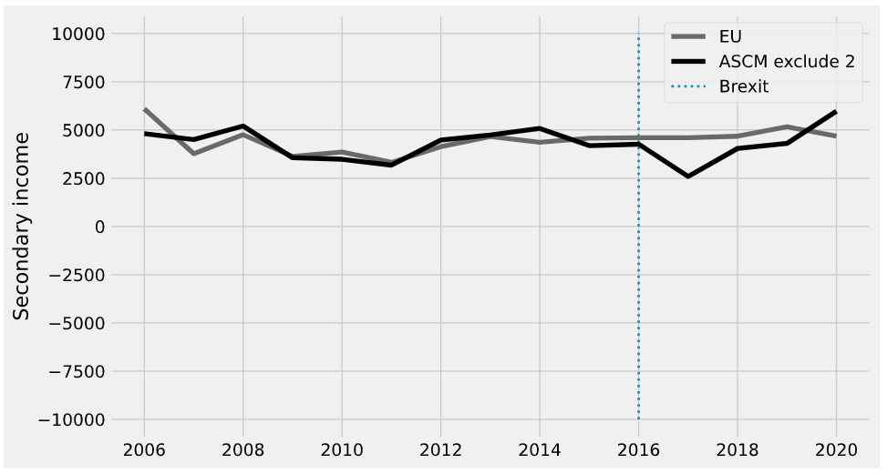

Figure . Brazil, Canada

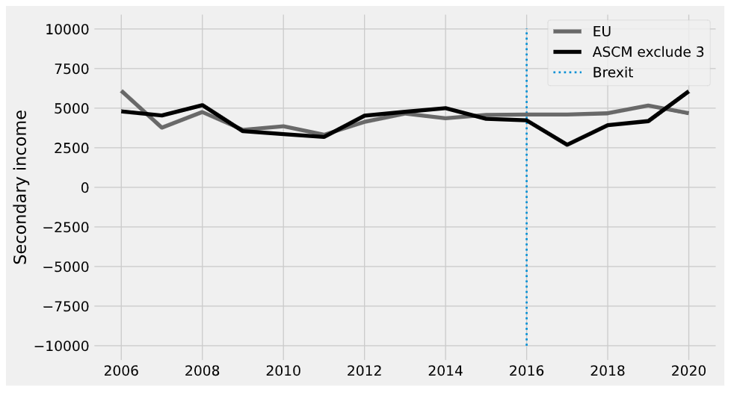

Figure . Brazil, Canada, China

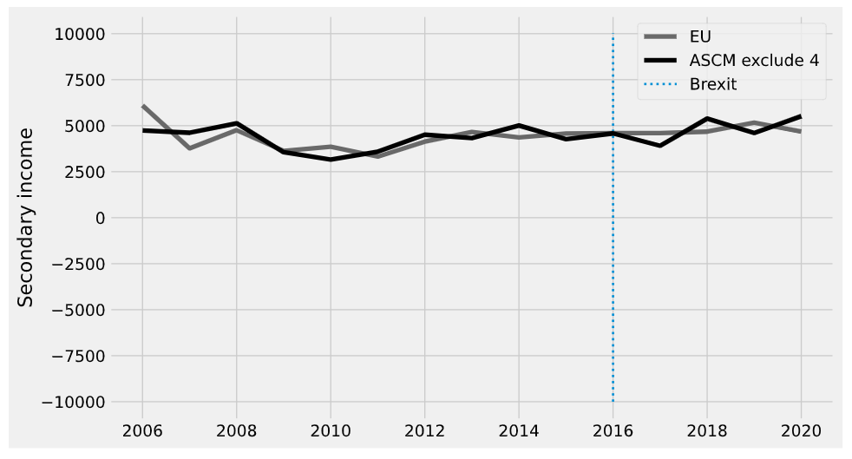

Figure . Brazil, Canada, China, India

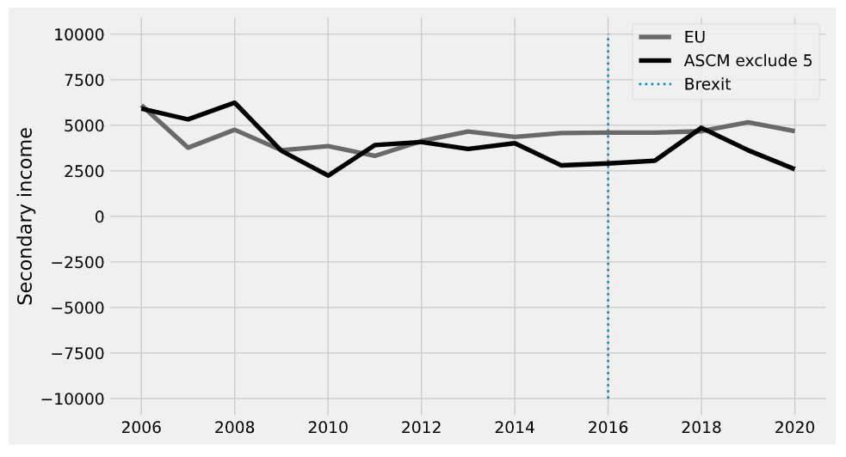

Figure . Brazil, Canada, China, India, Japan

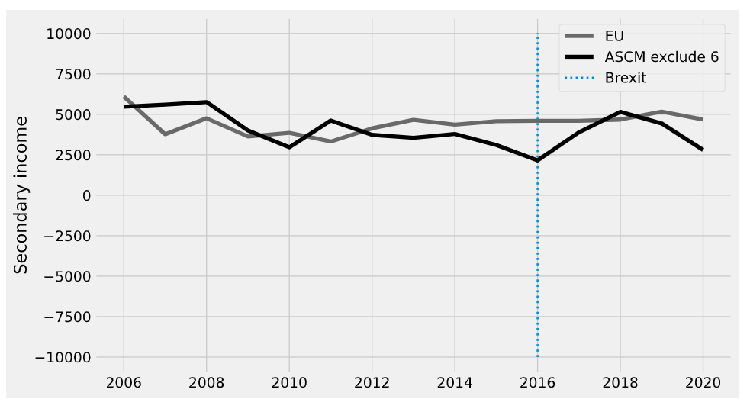

Figure . Brazil, Canada, China, India, Japan, Russia

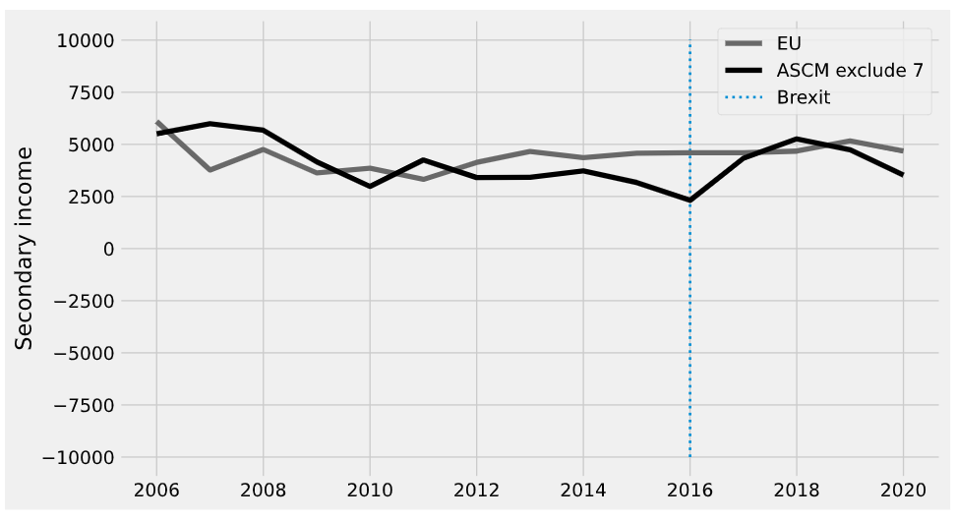

Figure . Brazil, Canada, China, India, Japan, Russia, Switzerland

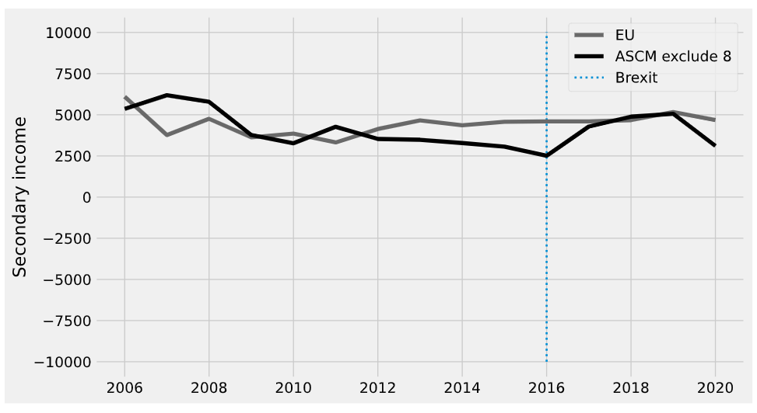

Figure . Brazil, Canada, China, India, Japan, Russia, Switzerland, USA

Link to code comprehension

https://github.com/Jaykim1234/Python/blob/main/UvA%20material/Thesis/Impact%20of%20Brexit%20thesis%20on%20the%20EU%20economy.ipynb

import pandas as pd

import os

dirs = os.getcwd()

files = os.listdir(dirs)

files

import warnings

import copy

import pandas as pd

import numpy as np

import seaborn as sns

import statsmodels.formula.api as smf

import os

from typing import List

from operator import add

from toolz import reduce, partial

from scipy import stats

from scipy.optimize import fmin_slsqp

from scipy.stats import ttest_ind

from sklearn.preprocessing import StandardScaler

from sklearn.linear_model import LinearRegression,Ridge

from matplotlib import style

from matplotlib import pyplot as plt

from matplotlib.colors import LogNorm

warnings.filterwarnings('ignore')

%matplotlib inline

pd.set_option("display.max_columns", 6)

style.use("fivethirtyeight")

# read data file

# pandas read_csv

dirs = os.getcwd()

files = os.listdir(dirs)

data_c = pd.read_csv('all_data_total_EU_GDP_CA_1.csv')

data_c = data_c.loc[data_c.year >= 2006]

raw_data_c = copy.deepcopy(data_c)# Copy dataframe

data_g = pd.read_csv('all_data_total_EU_export_of_Goods_eu_GDP_1.csv')

data_g = data_g.loc[data_g.year >= 2006]

raw_data_g = copy.deepcopy(data_g)# Copy dataframe

data_s = pd.read_csv('all_data_total_EU_export_of_Service_eu_GDP_1.csv')

data_s = data_s.loc[data_s.year >= 2006]

raw_data_s = copy.deepcopy(data_s)# Copy dataframe

data_g_s = pd.read_csv('all_data_total_EU_export_of_goods_service_eu_GDP_1.csv')

data_g_s = data_g_s.loc[data_g_s.year >= 2006]

raw_data_g_s = copy.deepcopy(data_g_s)# Copy dataframe

data_primary = pd.read_csv('all_data_total_EU_primary_income_eu_GDP_1.csv')

data_primary = data_primary.loc[data_primary.year >= 2006]

raw_data_primary = copy.deepcopy(data_primary)# Copy dataframe

data_secondary = pd.read_csv('all_data_total_EU_secondary_income_eu_GDP_1.csv')

data_secondary = data_secondary.loc[data_secondary.year >= 2006]

raw_data_secondary = copy.deepcopy(data_secondary)# Copy dataframe

# Standardize independent variables

# mean 0 / variance 1

data_c[['inflation','education','unemployment rate','GDP growth rate']] = StandardScaler().fit_transform(data_c[['inflation','education','unemployment rate','GDP growth rate']])

data_g[['inflation','education','unemployment rate','GDP growth rate']] = StandardScaler().fit_transform(data_g [['inflation','education','unemployment rate','GDP growth rate']])

data_s[['inflation','education','unemployment rate','GDP growth rate']] = StandardScaler().fit_transform(data_s[['inflation','education','unemployment rate','GDP growth rate']])

data_g_s[['inflation','education','unemployment rate','GDP growth rate']] = StandardScaler().fit_transform(data_g_s[['inflation','education','unemployment rate','GDP growth rate']])

data_primary[['inflation','education','unemployment rate','GDP growth rate']] = StandardScaler().fit_transform(data_primary[['inflation','education','unemployment rate','GDP growth rate']])

data_secondary[['inflation','education','unemployment rate','GDP growth rate']] = StandardScaler().fit_transform(data_secondary[['inflation','education','unemployment rate','GDP growth rate']])

def visulaize_origianl(data0, country,interested_variable):

  """

  Make graph with interested variable and country

  This function is to visulize the raw data

  """

  # Make data0set that is only about entered country

  str_expr = f"country == '{country}' "

  data0_new = data0.query(str_expr)

  plt.figure(figsize=(10,5))

  plt.plot(data0['year'],data0[interested_variable],marker="o",alpha=.6, label = f'{interested_variable} with Non {country}',color='dimgray')

  plt.plot(data0_new['year'],data0_new[interested_variable],'R',label = f'{interested_variable} with {country}',color='black')

  plt.vlines(x=2016,   ymin=-200000, ymax=200000, linestyle=":", lw=2, label="Brexit")

  plt.gray()

  plt.legend();

  plt.show()

def X_y(country, main_variable, data0):

  """

   Get X and y

  """

  features = [ 'inflation',"education",'unemployment rate','GDP growth rate']

  #Make new dummy variable 'Brexit'

  data0['Brexit'] = [1 if t else 0 for t in list(data0['year'] > 2016.0)]

  # make data only about selected country

  str_expr = f"country == '{country}' "

  data0_country = data0.query(str_expr)

  # .T  flip the table to have one column per state

  inverted = data0.query("Brexit == 0").pivot(index='country', columns="year")[features].T

  # Replace the missing value

  inverted = inverted.fillna(method='pad')

  # Set X and y

  y = inverted[country].values

  X = inverted.drop(columns= country).values

  return X,y

def loss_w(W, X, y) -> float:

    return np.sqrt(np.mean((y - X.dot(W))**2))

def get_w(X, y):

    w_start = [1/X.shape[1]]*X.shape[1]

    weights = fmin_slsqp(partial(loss_w, X=X, y=y),

                         np.array(w_start),

                         f_eqcons=lambda x: np.sum(x) - 1,

                         bounds=[(0.0, 1.0)]*len(w_start),

                         disp=False)

    return weights

def sythetic_weight(country, interested_variable, data0):

  """

  Get the weight of synthetic control.

  """

  data_weights = get_w(X_y(country, interested_variable, data0)[0], X_y(country, interested_variable, data0)[1])

  print("Sum of weight:", data_weights.sum())

  return np.round(data_weights, 4)

def synthetic_control(country, main_variable, data0):

  """

  This function is to generate the value of Synthetic Control

  Country : The country you want to see

  pool: list of country in data set

  main_variable: Variable you want to see. ex) CA

  data0 : data that you have

  """

  #Make new dummy variable 'Brexit'

  data0['Brexit'] = [1 if t else 0 for t in list(data0['year'] > 2016.0)]

  # make data only about selected country

  str_expr = f"country == '{country}' "

  data0_country = data0.query(str_expr)

  # .T  flip the table to have one column per state

  features = [main_variable,'unemployment rate', "education",'inflation','GDP growth rate']

  inverted = data0.query("Brexit == 0").pivot(index='country', columns="year")[features].T

  # Replace the missing value

  inverted = inverted.fillna(method='pad')

  # Set X and y

  y = inverted[country].values

  X = inverted.drop(columns= country).values

  # Find the synthetic controls of countries in the pool or a given dataset

  weights_synth = sythetic_weight(country, main_variable, data0)

  weights_synth.round(3)

  #select countries without country and make tables about main variable entered

  data1 = data0.query(f"country != '{country}' ").pivot(index='year', columns="country")[main_variable]

  # multiply values of main variable with weight that we have gotten

  data_synth_lr = data1.values.dot(weights_synth)

  data0_country['Synthetic'] = data_synth_lr

  return data0_country

def synthetic_control_dataframe(country, main_variable, data0):

  """

  This function is to make dataframe that contain the value of Synthetic Control

  Country : The country you want to see

  pool: list of country in data set

  main_variable: Variable you want to see. ex) CA

  data0 : data that you have

  """

  # Deepcopy dataframe

  data1 = copy.deepcopy(data0)

  # Make dataframe that contain values of augmented synthetic control

  data2 = synthetic_control(country, main_variable, data1)

  # Add column of difference

  data2[f'Difference'] = data2[main_variable]- data2['Synthetic']

  # Make dataframe that contain pre-treatment period only

  data_pre = data2.loc[data2.year <= 2016]

  # Make dataframe that contain post-treatment period only

  data_post = data2.loc[data2.year > 2016]

  # Calculate RMSPE for pre-treatment period only

  rmspe = rmse(data_pre[main_variable], data_pre['Synthetic'])

  print('Pre- RMSPE :', rmspe )

  # Calculate RMSPE for post-treatment period only

  rmspe = rmse(data_post[main_variable], data_post['Synthetic'])

  print('Post- RMSPE :', rmspe )

  return data2[['country','year',main_variable,'Synthetic','Difference']]

def synthetic_plot(country,main_variable, data0):

  """

  Show the plot of synthetic control

  """

  features = [main_variable]

  data_synth_1 = data0.query(f"country != '{country}' ").pivot(index='year', columns="country")[features].values.dot(sythetic_weight(country, 'CA', data0))

  plt.figure(figsize=(10,6))

  plt.plot(data0.query(f"country == '{country}'")["year"], data0.query(f"country == '{country}'")[features], label=f"{country}",color='dimgray')

  plt.plot(data0.query(f"country == '{country}'")["year"], data_synth_1, label="Synthetic Control",color='black')

  plt.vlines(x=2016, ymin=-200000, ymax=200000, linestyle=":", lw=2, label="Brexit")

  plt.ylabel(f"{main_variable} ")

  plt.legend();

def synthetic_plot_magnified(country,main_variable, data0):

  """

  Show the plot of synthetic control with samll values of main_variable

  """

  features = [main_variable]

  data_synth_1 = data0.query(f"country != '{country}' ").pivot(index='year', columns="country")[features].values.dot(sythetic_weight(country, 'CA', data0))

  plt.figure(figsize=(10,6))

  plt.plot(data0.query(f"country == '{country}'")["year"], data0.query(f"country == '{country}'")[features], label=f"{country}",color='dimgray')

  plt.plot(data0.query(f"country == '{country}'")["year"], data_synth_1, label="Synthetic Control",color='black')

  plt.vlines(x=2016, ymin=-5000, ymax=5000, linestyle=":", lw=2, label="Brexit")

  plt.ylabel(f"{main_variable} ")

  plt.legend();

def agumented_synthetic_control(country, main_variable, data0):

  """

  This function is to make dataframe that contain the value of ASCM

  Country : The country you want to see

  pool: list of country in data set

  main_variable: Variable you want to see. ex) CA

  data0 : data that you have

  """

  #Make new dummy variable 'Brexit'

  data0['Brexit'] = [1 if t else 0 for t in list(data0['year'] > 2016.0)]

  # make data only about selected country

  str_expr = f"country == '{country}' "

  data0_country = data0.query(str_expr)

  # .T  flip the table to have one column per state

  features = [main_variable,'unemployment rate', "education",'inflation','GDP growth rate']

  inverted = data0.query("Brexit == 0").pivot(index='country', columns="year")[features].T

  # Replace the missing value

  inverted = inverted.fillna(method='pad')

  # Set X and y

  y = inverted[country].values

  X = inverted.drop(columns= country).values

  # Find the weight of countries in the pool or a given dataset

  weights_ridge = Ridge(fit_intercept=False).fit(X, y).coef_

  weights_ridge.round(3)

  #select countries without country and make tables about main variable entered

  data1 = data0.query(f"country != '{country}' ").pivot(index='year', columns="country")[main_variable]

  # multiply values of main variable with weight that we have gotten

  data_synth_lr = data1.values.dot(weights_ridge)

  data0_country['ASCM'] = data_synth_lr

  return data0_country

def rmse(y_true, y_pred):

    '''

    Compute Root Mean Square Percentage Error between two arrays.

    '''

    loss = np.sqrt(np.mean(np.square(((y_true - y_pred) / y_true)), axis=0))

    return loss

def agumented_synthetic_control_dataframe(country, main_variable, data0):

  # Deepcopy dataframe

  data1 = copy.deepcopy(data0)

  # Make dataframe that contain values of augmented synthetic control

  data2 = agumented_synthetic_control(country, main_variable, data1)

  # Add column of difference

  data2['Difference'] = data2[main_variable]- data2['ASCM']

  # Make dataframe that contain pre-treatment period only

  data_pre = data2.loc[data2.year <= 2016]

  # Make dataframe that contain post-treatment period only

  data_post = data2.loc[data2.year > 2016]

  # Calculate RMSPE for pre-treatment period only

  rmspe = rmse(data_pre[main_variable], data_pre['ASCM'])

  print('Pre- RMSPE :', rmspe )

  # Calculate RMSPE for post-treatment period only

  rmspe = rmse(data_post[main_variable], data_post['ASCM'])

  print('Post- RMSPE :', rmspe )

  return data2[['country','year',main_variable,'ASCM','Difference']]

# Country : The country you want to see

# main_variable: Variable you want to see. ex) CA

# data0 : data that you have

def agumented_weight_visualize(country, main_variable, data0):

  """

  This function is for showing the weight of countries from ridge ASMC

  # Country : The country you want to see

  # main_variable: Variable you want to see. ex) CA

  # data0 : data that you have

  """

  #Make new dummy variable 'Brexit'

  data0['Brexit'] = [1 if t else 0 for t in list(data0['year'] > 2016.0)]

  # make data only about selected country

  str_expr = f"country == '{country}' "

  data0_country = data0.query(str_expr)

  # .T  flip the table to have one column per state

  features = [main_variable,'unemployment rate', "education",'inflation','GDP growth rate']

  inverted = data0.query("Brexit == 0").pivot(index='country', columns="year")[features].T

  # Replace the missing value

  inverted = inverted.fillna(method='pad')

  # Set X and y

  y = inverted[country].values

  X = inverted.drop(columns= country).values

  # Find the weight of countries in the pool or a given dataset

  weights_ridge = Ridge(fit_intercept=False).fit(X, y).coef_

  weights_ridge_rounded = weights_ridge.round(3)

  # Show weight of countries in the pool

  pool = list(data0['country'].unique())

  dic = {}

  for index in range(len(pool)-1):

    dic[pool[index]] = weights_ridge_rounded[index]

  return dic

# Country : The country you want to see

# pool: list of country in data set

# main_variable: Variable you want to see. ex) CA

# data0 : data that you have

def agumented_synthetic_control_visualize(country, main_variable, data0):

  #Make new dummy variable 'Brexit'

  data0['Brexit'] = [1 if t else 0 for t in list(data0['year'] > 2016.0)]

  # make data only about selected country

  str_expr = f"country == '{country}' "

  data0_country = data0.query(str_expr)

  # .T  flip the table to have one column per state

  features = [main_variable,'unemployment rate', "education",'inflation','GDP growth rate']

  inverted = data0.query("Brexit == 0").pivot(index='country', columns="year")[features].T

  # Replace the missing value

  inverted = inverted.fillna(method='pad')

  # Set X and y

  y = inverted[country].values

  X = inverted.drop(columns= country).values

  # Find the weight of countries in the pool or a given dataset/ Calculate the weight through Ridge regression.

  weights_ridge = Ridge(fit_intercept=False).fit(X, y).coef_

  # Show weight of countries in the pool

  pool = list(data0['country'].unique())

  #select countries without country and make tables about main variable entered

  data1 = data0.query(f"country != '{country}' ").pivot(index='year', columns="country")[main_variable]

  # multiply values of main variable with weight that we have gotten

  data_synth_lr = data1.values.dot(weights_ridge)

  plt.figure(figsize=(10,6))

  plt.plot(data0.query(f"country == '{country}'")["year"], data0.query(f"country == '{country}'")[main_variable], label=f"{country}",color='dimgray')

  plt.plot(data0.query(f"country == '{country}'")["year"], data_synth_lr, label="Augmented Synthetic Control",color='black')

  plt.vlines(x=2016,  ymin=-200000, ymax=200000, linestyle=":", lw=2, label="Brexit")

  plt.ylabel(f"{main_variable}")

  plt.legend();

def rmse(y_true, y_pred):

    '''

    Compute Root Mean Square Percentage Error between two arrays.

    '''

    loss = np.sqrt(np.mean(np.square(((y_true - y_pred) / y_true)), axis=0))

    return loss

def rmspe_table(main_variable, data0):

  print('*'*300)

  # Deepcopy dataframe

  data1 = copy.deepcopy(data0)

  # Make list that contain names of countries

  pool = list(data1['country'].unique())

  for each_country in pool:

    # Make dataframe that contain values of augmented synthetic control

    data2 = agumented_synthetic_control(each_country, main_variable, data1)

    # Add column of difference

    data2['Difference'] = data2[main_variable]- data2['ASCM']

    # Make dataframe that contain pre-treatment period only

    data_pre = data2.loc[data2.year <= 2016]

    # Make dataframe that contain post-treatment period only

    data_post = data2.loc[data2.year > 2016]

    print('*'*300)

    print('<',each_country,'>')

    print('')

    # Calculate RMSPE for pre-treatment period only

    rmspe_pre = rmse(data_pre[main_variable], data_pre['ASCM'])

    print(f'Pre- RMSPE :', rmspe_pre )

    print('')

    # Calculate RMSPE for post-treatment period only

    rmspe_post = rmse(data_post[main_variable], data_post['ASCM'])

    print(f'Post- RMSPE :', rmspe_post )

    print('')

    print('Ratio Post_RMSPE/Pre_RMSPE : ',rmspe_post/rmspe_pre )

    print('')

    print('*'*300)

def placebo_visualize(interested_country, interested_variable, input_data):

  # Make dataframe that contains

  # Make a list of country in a dataset

  pool = list(input_data['country'].unique())

  synth_list = []

  for country in pool:

    # Make temporary dataframe that contains synthetic values

    temp_dataframe = agumented_synthetic_control(country, interested_variable, input_data)

    synth_list.append(temp_dataframe)

  # Make gahtered data

  data_synth_all= pd.concat(synth_list, axis = 0, sort= False)

  # Make a plot for all country except interested_country

  plt.figure(figsize=(10,6))

  plt.plot(data_synth_all['year'],data_synth_all[f'{interested_variable}']-data_synth_all['ASCM'],marker="o",alpha=.6, label = 'placebo effect',color='dimgray')

  # Make a plot for interested country

  temp_dataframe2 = agumented_synthetic_control(interested_country, interested_variable, input_data)

  plt.plot(temp_dataframe2['year'],temp_dataframe2[f'{interested_variable}']-temp_dataframe2['ASCM'], alpha=.6, label = f'Brexit impact on {interested_country}',color='black')

  plt.vlines(x=2016, ymin=-100000, ymax=200000, linestyle=":", lw=2, label="Brexit")

  plt.ylabel("")

  plt.legend();

  plt.show()

def p_value_analysis(interested_country, interested_variable, input_data):

  """

  Note

  Treatment effect = the value of interested varaible - value of Agumented synthetic control ( The subject here is the interested country)

  Placebo effect = the value of interested varaible - value of Agumented synthetic control ( The subject here is the all the other country except the main country)

  P-value is calculated with following two steps

  - 1st step : Count the number of placebo effects that have larger absolute values than those of treatment effects.

  - 2nd step : Divide the value from 1st step by the total number of countries

  """

  # Make list that contains sum of absolute placebo effect value

  placebo_all_year = []

  # Make list that contains sum of absolute treatment effect value

  treatment_all_year = []

  # Make a list of country in a dataset

  pool = list(input_data['country'].unique())

  # Make list of year in a dataframe

  pool_year = list(input_data['year'].unique())

  current_year = 2016

  for year in range(-4,0):# year is -4,-3,-2,-1 . This is to select ASCM from 2016 to 2020

    synth_list = []

    current_year += 1

    for country in pool:

      # Make temporary dataframe that contains synthetic values

      temp_dataframe = agumented_synthetic_control(country, interested_variable, input_data)

      # print(temp_dataframe)

      value_agumented_synthetic_control    = temp_dataframe.iloc[year,-1] # (left: row), (right:column)

      value_interested_variable  = temp_dataframe.iloc[year,2]

      # print(value_interested_variable, value_synthetic_control)

      placebo_effect = value_interested_variable - value_agumented_synthetic_control

      synth_list.append(placebo_effect)

    # Calculate synthetic value for interested country in 2020 year

    synth_interested_country = agumented_synthetic_control(interested_country, interested_variable, input_data)

    value_agumented_synthetic_control_main_country = synth_interested_country.iloc[year,-1]

    value_interested_variable_main_country = synth_interested_country.iloc[year,2]

    treatment_effect = value_interested_variable_main_country - value_agumented_synthetic_control_main_country

    treatment_all_year.append(abs(treatment_effect))

    # Make dictionray to summarise placebo effect

    placebo_effect_dictionary = {}

    for now_country, placebo_value in zip(pool[0:-1],synth_list[0:-1]):

      placebo_effect_dictionary[now_country] = placebo_value

    print('Placebo effects:',placebo_effect_dictionary )

    # Make a new list that contains placebo effects which are larger than the treatment effect

    sorted_list= [placebo_effect for placebo_effect in synth_list if abs(placebo_effect) > abs(treatment_effect)]

    p_value = len(sorted_list)/(len(synth_list)-1) # -1: exclude the interested country in the list

    # Print treament effect

    print(f'Brexit Treatment Effect for the Year {current_year} ({interested_country}): {treatment_effect}')

    print(f'p-value : {p_value}')

    print('')

    print('')

def agumented_synthetic_control_visualize_limit_donor_pool(country, main_variable, data0):

    # print(list(data0['country'].unique())[-1:])

    country_list  = list(data0['country'].unique())

    count = 1

    while len(country_list) > 1 :

        data0 = data0.loc[data0.country.isin(country_list) == True]

        #Make new dummy variable 'Brexit'

        print('')

        print('Countries:', country_list[0:-1])

        data0['Brexit'] = [1 if t else 0 for t in list(data0['year'] > 2016.0)]

        # make data only about selected country

        str_expr = f"country == '{country}' "

        data0_country = data0.query(str_expr)

        # .T  flip the table to have one column per state

        features = [main_variable,'unemployment rate', "education",'inflation','GDP growth rate']

        inverted = data0.query("Brexit == 0").pivot(index='country', columns="year")[features].T

        # Replace the missing value

        inverted = inverted.fillna(method='pad')

        # Set X and y

        y = inverted[country].values

        X = inverted.drop(columns= country).values

        # Find the weight of countries in the pool or a given dataset/ Calculate the weight through Ridge regression.

        weights_ridge = Ridge(fit_intercept=False).fit(X, y).coef_

        print('Weights:', weights_ridge)

        # Show weight of countries in the pool

        pool = list(data0['country'].unique())

        #select countries without country and make tables about main variable entered

        data1 = data0.query(f"country != '{country}' ").pivot(index='year', columns="country")[main_variable]

        # multiply values of main variable with weight that we have gotten

        data_synth_lr = data1.values.dot(weights_ridge)

        plt.figure(figsize=(10,6))

        plt.plot(data0.query(f"country == '{country}'")["year"], data0.query(f"country == '{country}'")[main_variable], label=f"{country}",color='dimgray')

        plt.plot(data0.query(f"country == '{country}'")["year"], data_synth_lr, label=f"ASCM exclude {count}",color='black')

        plt.vlines(x=2016,  ymin=-200000, ymax=200000, linestyle=":", lw=2, label="Brexit")

        plt.ylabel(f"{main_variable}")

        plt.legend();

        country_list.pop(0)

        count += 1

def agumented_synthetic_control_visualize_limit_donor_pool_magnified(country, main_variable, data0):

    """

    Visualize variable with small values

    """

    country_list  = list(data0['country'].unique())

    count = 1

    while len(country_list) > 1 :

        data0 = data0.loc[data0.country.isin(country_list) == True]

        #Make new dummy variable 'Brexit'

        print('')

        print('Countries:', country_list[0:-1])

        data0['Brexit'] = [1 if t else 0 for t in list(data0['year'] > 2016.0)]

        # make data only about selected country

        str_expr = f"country == '{country}' "

        data0_country = data0.query(str_expr)

        # .T  flip the table to have one column per state

        features = [main_variable,'unemployment rate', "education",'inflation','GDP growth rate']

        inverted = data0.query("Brexit == 0").pivot(index='country', columns="year")[features].T

        # Replace the missing value

        inverted = inverted.fillna(method='pad')

        # Set X and y

        y = inverted[country].values

        X = inverted.drop(columns= country).values

        # Find the weight of countries in the pool or a given dataset/ Calculate the weight through Ridge regression.

        weights_ridge = Ridge(fit_intercept=False).fit(X, y).coef_

        print('Weights:', weights_ridge)

        # Show weight of countries in the pool

        pool = list(data0['country'].unique())

        #select countries without country and make tables about main variable entered

        data1 = data0.query(f"country != '{country}' ").pivot(index='year', columns="country")[main_variable]

        # multiply values of main variable with weight that we have gotten

        data_synth_lr = data1.values.dot(weights_ridge)

        plt.figure(figsize=(10,6))

        plt.plot(data0.query(f"country == '{country}'")["year"], data0.query(f"country == '{country}'")[main_variable], label=f"{country}",color='dimgray')

        plt.plot(data0.query(f"country == '{country}'")["year"], data_synth_lr, label=f"ASCM exclude {count}",color='black')

        plt.vlines(x=2016,  ymin=-10000, ymax=10000, linestyle=":", lw=2, label="Brexit")

        plt.ylabel(f"{main_variable}")

        plt.legend();

        country_list.pop(0)

        count += 1